**JVM, JDK and JRE:**

The Java Virtual machine (JVM) is the virtual machine that run the Java bytecodes. The JVM doesn't understand Java typo, that's why you compile your \*.java files to obtain \*.class files that contain the bytecodes understandable by the JVM. It's also the entity that allows Java to be a "portable language" (write once, run anywhere). Indeed there are specific implementations of the JVM for different systems (Windows, Linux, MacOS, see the wikipedia list..), the aim is that with the same bytecodes they all give the same results.

As we all aware when we compile a Java file, output is not an ‘exe’ but it’s a ‘.class’ file. ‘.class’ file consists of Java byte codes which are understandable by JVM. Java Virtual Machine interprets the byte code into the machine code depending upon the underlying operating system and hardware combination. It is responsible for all the things like garbage collection, array bounds checking, etc… JVM is platform dependent.

**JRE**:

Java Runtime Environment (JRE) The Java Runtime Environment (JRE) provides the libraries, the Java Virtual Machine, and other components to run applets and applications written in the Java programming language. In addition, two key deployment technologies are part of the JRE: Java Plug-in, which enables applets to run in popular browsers; and Java Web Start, which deploys standalone applications over a network. It is also the foundation for the technologies in the Java 2 Platform, Enterprise Edition (J2EE) for enterprise software development and deployment. The JRE does not contain tools and utilities such as compilers or debuggers for developing applets and applications.

Java Runtime Environment contains JVM, class libraries, and other supporting files. It does not contain any development tools such as compiler, debugger, etc. Actually JVM runs the program, and it uses the class libraries, and other supporting files provided in JRE. If you want to run any java program, you need to have JRE installed in the system

**JDK**:

Java Development Kit (JDK) The JDK is a superset of the JRE, and contains everything that is in the JRE, plus tools such as the compilers and debuggers necessary for developing applets and applications.

Java Developer Kit contains tools needed to develop the Java programs, and JRE to run the programs. The tools include compiler (javac.exe), Java application launcher (java.exe), Appletviewer, etc… Compiler converts java code into byte code. Java application launcher opens a JRE, loads the class, and invokes its main method.

You need JDK, if at all you want to write your own programs, and to compile them. For running java programs, JRE is sufficient. JRE is targeted for execution of Java files i.e. JRE = JVM + Java Packages Classes(like util, math, lang, awt,swing etc)+runtime libraries. JDK is mainly targeted for java development. I.e. You can create a Java file (with the help of Java packages), compile a Java file and run a java file.

JVM is Java Virtual Machine -- the JVM actually runs Java bytecode.

JDK is Java Developer Kit -- the JDK is what you need to compile Java source code, JDK provides the environment to develop and run the java application

JRE is Java Runtime Environment -- is what you need to run a java program (not able develop the application using JRE) -- it contains a JVM, among other things.

JDK

|  |  |  |
| --- | --- | --- |
| Development kit   |  |  | | --- | --- | | JRE   |  | | --- | | JVM |   Libraries | |

**JDK = JRE + Development kit, JRE= JVM + Libraries**

**What is ClassLoader in Java**

ClassLoader in Java is a class which is used to load [class files in Java](http://javarevisited.blogspot.ca/2012/05/10-points-about-class-file-in-java.html). Java code is compiled into class file by [javac](http://javarevisited.blogspot.sg/2012/12/javac-is-not-recognized-as-internal-or-external-command.html)compiler and [JVM](http://javarevisited.blogspot.sg/2011/12/jre-jvm-jdk-jit-in-java-programming.html)executes Java program, by executing byte codes written in class file. ClassLoader is responsible for loading class files from file system, network or any other source. There are three default class loader used in Java, **Bootstrap** , **Extension** and **System or Application class loader**. Every class loader has a predefined location, from where they loads class files. Bootstrap ClassLoader is responsible for loading standard JDK class files from rt.jar and it is parent of all class loaders in Java. Bootstrap class loader don't have any parents, if you call String.class.getClassLoader() it will return null and any code based on that may throw [NullPointerException in Java](http://javarevisited.blogspot.com/2012/06/common-cause-of-javalangnullpointerexce.html). Bootstrap class loader is also known as**Primordial ClassLoader** in Java.  Extension ClassLoader delegates class loading request to its parent, Bootstrap and if unsuccessful, loads class form jre/lib/ext directory or any other directory pointed by java.ext.dirs system property. Extension ClassLoader in JVM is implemented by  sun.misc.Launcher$ExtClassLoader. Third default class loader used by JVM to load Java classes is called System or Application class loader and it is responsible for loading application specific classes from [CLASSPATH](http://javarevisited.blogspot.sg/2011/01/how-classpath-work-in-java.html) environment variable, -classpath or -cp command line option, Class-Path attribute of Manifest file inside JAR. Application class loader is a child of Extension ClassLoader and its implemented by sun.misc.Launcher$AppClassLoader class. Also, except Bootstrap class loader, which is implemented in native language mostly in C,  all  Java class loaders are implemented using java.lang.ClassLoader.

[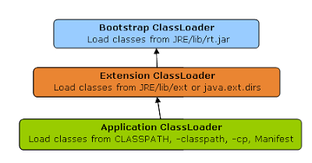](http://2.bp.blogspot.com/-HCTsr-j_ojw/USTOh1f8JwI/AAAAAAAAAjg/YegPspR5K48/s1600/java_classloader_hierarchy.PNG)

In short here is the location from which Bootstrap, Extension and Application ClassLoader load Class files.

1) Bootstrap ClassLoader - JRE/lib/rt.jar

2) Extension ClassLoader - JRE/lib/ext or any directory denoted by java.ext.dirs

3) Application ClassLoader - CLASSPATH environment variable, -classpath or -cp option, Class-Path attribute of Manifest inside [JAR file](http://javarevisited.blogspot.sg/2012/03/how-to-create-and-execute-jar-file-in.html).

## How ClassLoader works in Java

[](http://3.bp.blogspot.com/-K6q0DQ1v-tw/TWu8owBtc2I/AAAAAAAAADA/oBoHDBiJ8ag/s1600/17.jpg)As I explained earlier Java ClassLoader works in three principles : delegation, visibility and uniqueness. In this section we will see those rules in detail and understand working of Java ClassLoader with example. By the way here is a diagram which explains How ClassLoader load class in Java using delegation.

[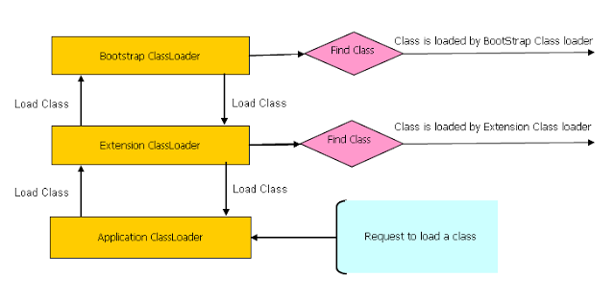](http://1.bp.blogspot.com/-0gOWex7Pb2E/USTOh2K7zpI/AAAAAAAAAjc/_viQADzxrsk/s1600/Java+classloader+working.PNG)

Read more: <http://javarevisited.blogspot.com/2012/12/how-classloader-works-in-java.html#ixzz432miStbu>

# What's New in JDK 8

Java Platform, Standard Edition 8 is a major feature release. This document summarizes features and enhancements in Java SE 8 and in JDK 8, Oracle's implementation of Java SE 8. Click the component name for a more detailed description of the enhancements for that component.

* [Java Programming Language](http://docs.oracle.com/javase/8/docs/technotes/guides/language/enhancements.html#javase8)
  + Lambda Expressions, a new language feature, has been introduced in this release. They enable you to treat functionality as a method argument, or code as data. Lambda expressions let you express instances of single-method interfaces (referred to as functional interfaces) more compactly.
  + Method references provide easy-to-read lambda expressions for methods that already have a name.
  + Default methods enable new functionality to be added to the interfaces of libraries and ensure binary compatibility with code written for older versions of those interfaces.
  + Repeating Annotations provide the ability to apply the same annotation type more than once to the same declaration or type use.
  + Type Annotations provide the ability to apply an annotation anywhere a type is used, not just on a declaration. Used with a pluggable type system, this feature enables improved type checking of your code.
  + Improved type inference.
  + Method parameter reflection.
* [Collections](http://docs.oracle.com/javase/8/docs/technotes/guides/collections/changes8.html)
  + Classes in the new java.util.stream package provide a Stream API to support functional-style operations on streams of elements. The Stream API is integrated into the Collections API, which enables bulk operations on collections, such as sequential or parallel map-reduce transformations.
  + Performance Improvement for HashMaps with Key Collisions
* [Compact Profiles](http://docs.oracle.com/javase/8/docs/technotes/guides/compactprofiles/) contain predefined subsets of the Java SE platform and enable applications that do not require the entire Platform to be deployed and run on small devices.
* [Security](http://docs.oracle.com/javase/8/docs/technotes/guides/security/enhancements-8.html)
  + Client-side TLS 1.2 enabled by default
  + New variant of AccessController.doPrivileged that enables code to assert a subset of its privileges, without preventing the full traversal of the stack to check for other permissions
  + Stronger algorithms for password-based encryption
  + SSL/TLS Server Name Indication (SNI) Extension support in JSSE Server
  + Support for AEAD algorithms: The SunJCE provider is enhanced to support AES/GCM/NoPadding cipher implementation as well as GCM algorithm parameters. And the SunJSSE provider is enhanced to support AEAD mode based cipher suites. See Oracle Providers Documentation, JEP 115.
  + KeyStore enhancements, including the new Domain KeyStore typejava.security.DomainLoadStoreParameter, and the new command option -importpassword for the keytool utility
  + SHA-224 Message Digests
  + Enhanced Support for NSA Suite B Cryptography
  + Better Support for High Entropy Random Number Generation
  + New java.security.cert.PKIXRevocationChecker class for configuring revocation checking of X.509 certificates
  + 64-bit PKCS11 for Windows
  + New rcache Types in Kerberos 5 Replay Caching
  + Support for Kerberos 5 Protocol Transition and Constrained Delegation
  + Kerberos 5 weak encryption types disabled by default
  + Unbound SASL for the GSS-API/Kerberos 5 mechanism
  + SASL service for multiple host names
  + JNI bridge to native JGSS on Mac OS X
  + Support for stronger strength ephemeral DH keys in the SunJSSE provider
  + Support for server-side cipher suites preference customization in JSSE
* [JavaFX](http://docs.oracle.com/javase/8/javase-clienttechnologies.htm)
  + The new Modena theme has been implemented in this release. For more information, see the blog at [fxexperience.com](http://fxexperience.com/2013/03/modena-theme-update/).
  + The new SwingNode class enables developers to embed Swing content into JavaFX applications. See the [SwingNode](http://docs.oracle.com/javase/8/javafx/api/javafx/embed/swing/SwingNode.html) javadoc and [Embedding Swing Content in JavaFX Applications](http://docs.oracle.com/javase/8/javafx/interoperability-tutorial/embed-swing.htm).
  + The new UI Controls include the [DatePicker](http://docs.oracle.com/javase/8/javafx/api/javafx/scene/control/DatePicker.html) and the [TreeTableView](http://docs.oracle.com/javase/8/javafx/api/javafx/scene/control/TreeTableView.html) controls.
  + The javafx.print package provides the public classes for the JavaFX Printing API. See the [javadoc](http://docs.oracle.com/javase/8/javafx/api/javafx/print/package-summary.html) for more information.
  + The 3D Graphics features now include 3D shapes, camera, lights, subscene, material, picking, and antialiasing. The new Shape3D (Box, Cylinder, MeshView, and Spheresubclasses), SubScene, Material, PickResult, LightBase (AmbientLight andPointLight subclasses) , and SceneAntialiasing API classes have been added to the JavaFX 3D Graphics library. The Camera API class has also been updated in this release. See the corresponding class javadoc for javafx.scene.shape.Shape3D,javafx.scene.SubScene, javafx.scene.paint.Material,javafx.scene.input.PickResult, javafx.scene.SceneAntialiasing, and the[Getting Started with JavaFX 3D Graphics](http://docs.oracle.com/javase/8/javafx/graphics-tutorial/javafx-3d-graphics.htm) document.
  + The WebView class provides new features and improvements. Review [Supported Features of HTML5](http://docs.oracle.com/javase/8/javafx/embedded-browser-tutorial/index.html) for more information about additional HTML5 features including Web Sockets, Web Workers, and Web Fonts.
  + Enhanced text support including bi-directional text and complex text scripts such as Thai and Hindi in controls, and multi-line, multi-style text in text nodes.
  + Support for Hi-DPI displays has been added in this release.
  + The CSS Styleable\* classes became public API. See the [javafx.css](http://docs.oracle.com/javase/8/javafx/api/javafx/css/package-frame.html) javadoc for more information.
  + The new [ScheduledService](http://docs.oracle.com/javase/8/javafx/api/javafx/concurrent/ScheduledService.html) class allows to automatically restart the service.
  + JavaFX is now available for ARM platforms. JDK for ARM includes the base, graphics and controls components of JavaFX.
* [Tools](http://docs.oracle.com/javase/8/docs/technotes/tools/enhancements-8.html)
  + The jjs command is provided to invoke the Nashorn engine.
  + The java command launches JavaFX applications.
  + The java man page has been reworked.
  + The jdeps command-line tool is provided for analyzing class files.
  + Java Management Extensions (JMX) provide remote access to diagnostic commands.
  + The jarsigner tool has an option for requesting a signed time stamp from a Time Stamping Authority (TSA).
  + [Javac tool](http://docs.oracle.com/javase/8/docs/technotes/guides/javac/index.html)
    - The -parameters option of the javac command can be used to store formal parameter names and enable the Reflection API to retrieve formal parameter names.
    - The type rules for equality operators in the Java Language Specification (JLS) Section 15.21 are now correctly enforced by the javac command.
    - The javac tool now has support for checking the content of javadoc comments for issues that could lead to various problems, such as invalid HTML or accessibility issues, in the files that are generated when javadoc is run. The feature is enabled by the new -Xdoclint option. For more details, see the output from running "javac -X". This feature is also available in the javadoc tool, and is enabled there by default.
    - The javac tool now provides the ability to generate native headers, as needed. This removes the need to run the javah tool as a separate step in the build pipeline. The feature is enabled in javac by using the new -h option, which is used to specify a directory in which the header files should be written. Header files will be generated for any class which has either native methods, or constant fields annotated with a new annotation of type java.lang.annotation.Native.
  + [Javadoc tool](http://docs.oracle.com/javase/8/docs/technotes/guides/javadoc/whatsnew-8.html)
    - The javadoc tool supports the new DocTree API that enables you to traverse Javadoc comments as abstract syntax trees.
    - The javadoc tool supports the new Javadoc Access API that enables you to invoke the Javadoc tool directly from a Java application, without executing a new process. See the [javadoc what's new](http://docs.oracle.com/javase/8/docs/technotes/guides/javadoc/whatsnew-8.html) page for more information.
    - The javadoc tool now has support for checking the content of javadoc comments for issues that could lead to various problems, such as invalid HTML or accessibility issues, in the files that are generated when javadoc is run. The feature is enabled by default, and can also be controlled by the new -Xdoclint option. For more details, see the output from running "javadoc -X". This feature is also available in the javac tool, although it is not enabled by default there.
* [Internationalization](http://docs.oracle.com/javase/8/docs/technotes/guides/intl/enhancements.8.html)
  + Unicode Enhancements, including support for Unicode 6.2.0
  + Adoption of Unicode CLDR Data and the java.locale.providers System Property
  + New Calendar and Locale APIs
  + Ability to Install a Custom Resource Bundle as an Extension
* [Deployment](http://docs.oracle.com/javase/8/docs/technotes/guides/jweb/enhancements-8.html)
  + For sandbox applets and Java Web Start applications, URLPermission is now used to allow connections back to the server from which they were started. SocketPermission is no longer granted.
  + The Permissions attribute is required in the JAR file manifest of the main JAR file at all security levels.
* [Date-Time Package](http://docs.oracle.com/javase/8/docs/technotes/guides/datetime/index.html) - a new set of packages that provide a comprehensive date-time model.
* [Scripting](http://docs.oracle.com/javase/8/docs/technotes/guides/scripting/enhancements.html#jdk8)
  + [Nashorn](http://docs.oracle.com/javase/8/docs/technotes/guides/scripting/nashorn/) Javascript Engine
* [Pack200](http://docs.oracle.com/javase/8/docs/technotes/guides/pack200/enhancements.html)
  + Pack200 Support for Constant Pool Entries and New Bytecodes Introduced by JSR 292
  + JDK8 support for class files changes specified by JSR-292, JSR-308 and JSR-335
* [IO and NIO](http://docs.oracle.com/javase/8/docs/technotes/guides/io/enhancements.html#jdk8)
  + New SelectorProvider implementation for Solaris based on the Solaris event port mechanism. To use, run with the system property java.nio.channels.spi.Selectorset to the value sun.nio.ch.EventPortSelectorProvider.
  + Decrease in the size of the <JDK\_HOME>/jre/lib/charsets.jar file
  + Performance improvement for the java.lang.String(byte[], \*) constructor and thejava.lang.String.getBytes() method.
* [java.lang and java.util Packages](http://docs.oracle.com/javase/8/docs/technotes/guides/lang/enhancements.html#jdk8)
  + Parallel Array Sorting
  + Standard Encoding and Decoding Base64
  + Unsigned Arithmetic Support
* [JDBC](http://docs.oracle.com/javase/8/docs/technotes/guides/jdbc/)
  + The JDBC-ODBC Bridge has been removed.
  + JDBC 4.2 introduces new features.
* Java DB
  + JDK 8 includes Java DB 10.10.
* [Networking](http://docs.oracle.com/javase/8/docs/technotes/guides/net/enhancements-8.0.html)
  + The class java.net.URLPermission has been added.
  + In the class java.net.HttpURLConnection, if a security manager is installed, calls that request to open a connection require permission.
* [Concurrency](http://docs.oracle.com/javase/8/docs/technotes/guides/concurrency/changes8.html)
  + Classes and interfaces have been added to the java.util.concurrent package.
  + Methods have been added to the java.util.concurrent.ConcurrentHashMap class to support aggregate operations based on the newly added streams facility and lambda expressions.
  + Classes have been added to the java.util.concurrent.atomic package to support scalable updatable variables.
  + Methods have been added to the java.util.concurrent.ForkJoinPool class to support a common pool.
  + The java.util.concurrent.locks.StampedLock class has been added to provide a capability-based lock with three modes for controlling read/write access.
* [Java XML](http://docs.oracle.com/javase/8/docs/technotes/guides/xml/enhancements.html) - [JAXP](http://docs.oracle.com/javase/8/docs/technotes/guides/xml/jaxp/enhancements-8.html)
* [HotSpot](http://docs.oracle.com/javase/8/docs/technotes/guides/vm/)
  + Hardware intrinsics were added to use Advanced Encryption Standard (AES). TheUseAES and UseAESIntrinsics flags are available to enable the hardware-based AES intrinsics for Intel hardware. The hardware must be 2010 or newer Westmere hardware. For example, to enable hardware AES, use the following flags:
  + -XX:+UseAES -XX:+UseAESIntrinsics

To disable hardware AES use the following flags:

-XX:-UseAES -XX:-UseAESIntrinsics

* + Removal of PermGen.
  + Default Methods in the Java Programming Language are supported by the byte code instructions for method invocation.
* [Java Mission Control 5.3 Release Notes](http://www.oracle.com/technetwork/java/javase/jmc53-release-notes-2157171.html)
  + JDK 8 includes Java Mission Control 5.3.

## Java SE 8

Java 8 was released on 18 March 2014. The code name culture is dropped with Java 8 and so no official code name going forward from Java 8.

### New features in Java SE 8

* Lambda Expressions
* Pipelines and Streams
* Date and Time API
* Default Methods
* Type Annotations
* Nashhorn JavaScript Engine
* Concurrent Accumulators
* Parallel operations
* PermGen Error Removed
* TLS SNI

## Java Version SE 7

## New features in Java SE 7

* Strings in switch Statement
* Type Inference for Generic Instance Creation
* Multiple Exception Handling
* Support for Dynamic Languages
* Try with Resources
* Java nio Package
* Binary Literals, underscore in literals
* Diamond Syntax
* Automatic null Handling

## Java Version SE 6

### New features in Java SE 6

* Scripting Language Support
* JDBC 4.0 API
* Java Compiler API
* Pluggable Annotations
* Native PKI, Java GSS, Kerberos and LDAP support.
* Integrated Web Services.
* Lot more enhancements.

## J2SE Version 5.0

### New features in J2SE 5.0

* Generics
* Enhanced for Loop
* Autoboxing/Unboxing
* Typesafe Enums
* Varargs
* Static Import
* Metadata (Annotations)
* Instrumentation

**Difference between path and ClassPath in Java:**

Class path is path where required class files are available or the path where exactly our class files needs to be store (like in eclipse we give store the class files at bin/src/packagename/classfiles)

Java Compiler will use class path to keep the class files while compiling the java files and JVM will use the class path to find the required class files to execute the application.

Path is the path where system to find the javac.exe file will search while compiling the java files. Whenever we compile the java file and it execute the javac.exe file (responsible for compilation) and it will find the javac.exe file from the path location. (if the correct path is not set then java commands will not work)

**ClassNotFoundError and ClassDefFoundError:**

if the hardcoded class name is not found then we get classDefFoundError and if dynamically given class name is not found at runtime then we will get ClassNotFoundException.

## OOPs (Object Oriented Programming System)

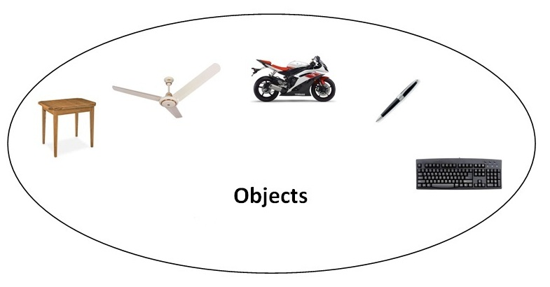**Object** means a real word entity such as pen, chair, table etc. **Object-Oriented Programming** is a methodology or paradigm to design a program using classes and objects. It simplifies the software development and maintenance by providing some concepts:

* Object
* Class
* Inheritance
* Polymorphism
* Abstraction
* Encapsulation

#### Object

Any entity that has state and behavior is known as an object. For example: chair, pen, table, keyboard, bike etc. It can be physical and logical.

#### Class

**Collection of objects** is called class. It is a logical entity.

#### Inheritance

**When one object acquires all the properties and behaviours of parent object** i.e. known as inheritance. It provides code reusability. It is used to achieve runtime polymorphism.

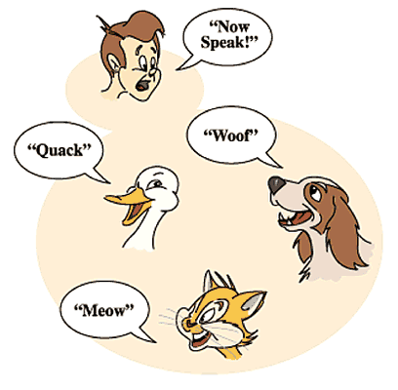

#### Polymorphism

When **one task is performed by different ways** i.e. known as polymorphism. For example: to convense the customer differently, to draw something e.g. shape or rectangle etc.

In java, we use method overloading and method overriding to achieve polymorphism.

Another example can be to speak something e.g. cat speaks meaw, dog barks woof etc.

#### Abstraction

**Hiding internal details and showing functionality** is known as abstraction. For example: phone call, we don't know the internal processing.

In java, we use abstract class and interface to achieve abstraction.



#### Encapsulation

**Binding (or wrapping) code and data together into a single unit is known as encapsulation**. For example: capsule, it is wrapped with different medicines.

A java class is the example of encapsulation. Java bean is the fully encapsulated class because all the data members are private here.

### Advantage of OOPs over Procedure-oriented programming language

|  |
| --- |
| 1)OOPs makes development and maintenance easier where as in Procedure-oriented programming language it is not easy to manage if code grows as project size grows. |
| 2)OOPs provides data hiding whereas in Procedure-oriented prgramming language a global data can be accessed from anywhere. |
| 3)OOPs provides ability to simulate real-world event much more effectively. We can provide the solution of real word problem if we are using the Object-Oriented Programming language. |

|  |  |
| --- | --- |
| Global Data | Object Data |

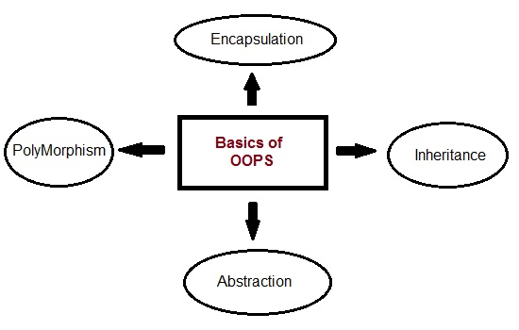

**1.What are the principle concepts of OOPS?**

There are four principle concepts upon which object oriented design and programming rest. They are:

* Abstraction
* Polymorphism
* Inheritance
* Encapsulation

(i.e. easily remembered as A-PIE).

**2.What is Abstraction?**

Abstraction refers to the act of representing essential features without including the background details or explanations.

**3.What is Encapsulation?**

Encapsulation is a technique used for hiding the properties and behaviors of an object and allowing outside access only as appropriate. It prevents other objects from directly altering or accessing the properties or methods of the encapsulated object.

**4.What is the difference between abstraction and encapsulation?**

* **Abstraction** focuses on the outside view of an object (i.e. the interface) **Encapsulation** (information hiding) prevents clients from seeing it’s inside view, where the behavior of the abstraction is implemented.
* **Abstraction** solves the problem in the design side while **Encapsulation** is the Implementation.
* **Encapsulation** is the deliverables of Abstraction. Encapsulation barely talks about grouping up your abstraction to suit the developer needs.

**5.What is Inheritance?**

* Inheritance is the process by which objects of one class acquire the properties of objects of another class.
* A class that is inherited is called a superclass.
* The class that does the inheriting is called a subclass.
* Inheritance is done by using the keyword extends.
* The two most common reasons to use inheritance are:
  + To promote code reuse
  + To use polymorphism

**6.What is Polymorphism?**

Polymorphism is briefly described as "one interface, many implementations." Polymorphism is a characteristic of being able to assign a different meaning or usage to something in different contexts - specifically, to allow an entity such as a variable, a function, or an object to have more than one form.

**Access Modifiers in Java:**

For class level you can only use Public and default access modifiers. Default Access modifier is only visible within the same package, if Class A and Class B are in different packages and Class A has default access modifier then Class B cannot access the Class A. In this case if you try to access the Class A from Class B compiler gives error (llegal modifier for the class MyDeadlock; only public, abstract & final are permitted).

**Why Strings are immutable:**

String pool (String intern pool) is a special storage area in Java heap. When a string is created and if the string already exists in the pool, the reference of the existing string will be returned, instead of creating a new object and returning its reference.

The following code will create only one string object in the heap.

String string1 = "abcd";

String string2 = "abcd";

If string is not immutable, changing the string with one reference will lead to the wrong value for the other references.

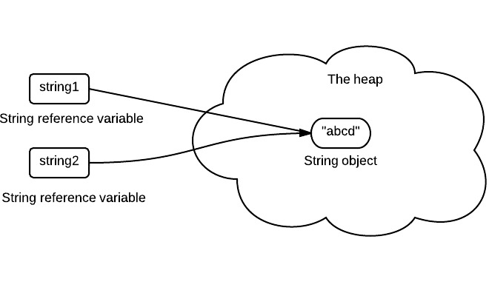

**2. Allow String to Cache its Hashcode**

The hashcode of string is frequently used in Java. For example, in a HashMap. Being immutable guarantees that hashcode will always the same, so that it can be cashed without worrying the changes.That means, there is no need to calculate hashcode every time it is used. This is more efficient.

**3. Security**

String is widely used as parameter for many java classes, e.g. network connection, opening files, etc. Were String not immutable, a connection or file would be changed and lead to serious security threat. The method thought it was connecting to one machine, but was not. Mutable strings could cause security problem in Reflection too, as the parameters are strings

4. collection safety. maps don't support mutations of keys, and strings are the most popular object to use as a key

5. defensiveness, you don't have to worry about a method you are calling changing the string out from under you

6. performance, there is an additional level of indirection needed to support sharing strings across some mutations (like growing the string)

7. thread safety/performance. the easiest way to guarantee safety and to cut down on use of synchronized blocks is to make your data immutable.

**Overloading and Overriding**

## The conditions for method overloading

1.) The ***number*** of parameters is different for the methods.

2.) The parameter ***types*** are different (like

changing a parameter that was a float to an int).

## How to NOT overload methods:

It’s also very important to understand that method overloading is NOT something that can be accomplished with either, or both, of these two things:

1. Just changing the return type of the method.

If the return type of the method is the only thing

changed, then this will result in a compiler error.

2. Changing just the name of the method parameters, but

not changing the parameter types. If the name of the

method parameter is the only thing changed then this

will also result in a compiler error.

|  |  |  |
| --- | --- | --- |
| **No.** | **Method Overloading** | **Method Overriding** |
| 1) | Method overloading is used *to increase the readability* of the program. | Method overriding is used *to provide the specific implementation* of the method that is already provided by its super class. |
| 2) | Method overloading is performed *within class*. | Method overriding occurs *in two classes* that have IS-A (inheritance) relationship. |
| 3) | In case of method overloading, *parameter must be different*. | In case of method overriding, *parameter must be*  *same*. |
| 4) | Method overloading is the example of *compile time polymorphism*. | Method overriding is the example of *run time*  *polymorphism*. |
| 5) | In java, method overloading can't be performed by changing return type of the method only. *Return type can be same or different* in method overloading. But you must have to change the parameter. | *Return type must be same or covariant* in method  overriding. |

If you method public String method1(String abc, String def) in parent class and you have method Public void method1(String abc, String def) in this case complier will give the error saying return type should be same.

In overloading if we have method public String method(String abc) and another method public void method(Date d) and you are calling method(null) then you will get compilation error. If you call method(“abc”) then it will invoke first method

**What is the difference between Parent P = new Child(); and Child C = new Child();**

If we know the exact type of object we are getting then we can use Child C = new Child(); but if we don’t know object type in compile time then we can use Parent P = new Child ();

For example we have added 10 objects in the arraylist and they may be of different types of object and while we retrieve the objects from arrayList and we don’t the type of object we are getting then we can use Object o= ArrayList.get(0);

For Child C= new Child(); in C object we can call any methods available in Child Class as well as its Parent Class methods. While in Parent P = new Child(); in P object we cannot call Child Specific methods. i.e, if any methods which are present only in Child class and not in parent class those methods we cant call from P object.

**Var-Arg methods**

Lets say we have method public void sum(int a, int b) and I will call this method sum(10,20) and again I want to call sum(10,20,30) then again I have write another method with three arguments, in same way if we want to call sum(10,20,30,40) then again we have write another method with four int type arguments. So the code becomes lengthy and not readable to overcome this in Java 1.5 version Sun has introduced new method called var-args methods.

The method signature for var-arg method is public void sum (int... a) now I can call sum(); sum(10) sum(10,20); sum(10,20,30) etc I call pass any number of parameters. Internally it will form a one dimenstional array[] it will process. Like if i call sum(10,20,30) then it will accept a[0] =10, a[1]=20, a[2]=30 and you can add sum=a[1]+a[2]+a[3]

**How to create immutable class in java**

1. Don’t provide “setter” methods — methods that modify fields or objects referred to by fields.

2) Make all fields final and private

3) Don’t allow subclasses to override methods –declare class as final

4) Special attention when having mutable instance variables – crate a private constructor

Always remember that your instance variables will be either mutable or immutable. Identify them and return new objects with copied content for all mutable objects. Immutable variables can be returned safely without extra effort.

A more sophisticated approach is to make the constructor private and construct instances in factory methods.

import java.util.Date;

/\*\*

\* Always remember that your instance variables will be either mutable or immutable.

\* Identify them and return new objects with copied content for all mutable objects.

\* Immutable variables can be returned safely without extra effort.

\* \*/

public final class ImmutableClass

{

    /\*\*

    \* Integer class is immutable as it does not provide any setter to change its content

    \* \*/

    private final Integer immutableField1;

    /\*\*

    \* String class is immutable as it also does not provide setter to change its content

    \* \*/

    private final String immutableField2;

    /\*\*

    \* Date class is mutable as it provide setters to change various date/time parts

    \* \*/

    private final Date mutableField;

    //Default private constructor will ensure no unplanned construction of class

    private ImmutableClass(Integer fld1, String fld2, Date date)

    {

        this.immutableField1 = fld1;

        this.immutableField2 = fld2;

        this.mutableField = new Date(date.getTime());

    }

    //Factory method to store object creation logic in single place

    public static ImmutableClass createNewInstance(Integer fld1, String fld2, Date date)

    {

        return new ImmutableClass(fld1, fld2, date);

    }

    //Provide no setter methods

    /\*\*

    \* Integer class is immutable so we can return the instance variable as it is

    \* \*/

    public Integer getImmutableField1() {

        return immutableField1;

    }

    /\*\*

    \* String class is also immutable so we can return the instance variable as it is

    \* \*/

    public String getImmutableField2() {

        return immutableField2;

    }

    /\*\*

    \* Date class is mutable so we need a little care here.

    \* We should not return the reference of original instance variable.

    \* Instead a new Date object, with content copied to it, should be returned.

    \* \*/

    public Date getMutableField() {

        return new Date(mutableField.getTime());

    }

    @Override

    public String toString() {

        return immutableField1 +" - "+ immutableField2 +" - "+ mutableField;

    }

}

class TestMain

{

    public static void main(String[] args)

    {

        ImmutableClass im = ImmutableClass.createNewInstance(100,"test", new Date());

        System.out.println(im);

        tryModification(im.getImmutableField1(),im.getImmutableField2(),im.getMutableField());

        System.out.println(im);

    }

    private static void tryModification(Integer immutableField1, String immutableField2, Date mutableField)

    {

        immutableField1 = 10000;

        immutableField2 = "test changed";

        mutableField.setDate(10);

    }

}

Output: (content is unchanged)

100 - test - Tue Oct 30 21:34:08 IST 2012

100 - test - Tue Oct 30 21:34:08 IST 2012

**Interface and Abstarct Class:**

Interface is you are forcing your client to implement some specified thing, implementation will be remain to the client. Also java doesn't support multiple inheritance by extending multiple classes you can have multiple interface implemented.

For example : List declares add(..) method all the implementation of List provides it implementations.

You define an Interface Animal and a method speak() it means all Animal must will have to speak with different different implementation. Man will speak,Dog will bark,Lion will roar.

**Consider using abstract classes if any of these statements apply to your situation:**

* You want to share code among several closely related classes.
* You expect that classes that extend your abstract class have many common methods or fields, or require access modifiers other than public (such as protected and private).
* You want to declare non-static or non-final fields. This enables you to define methods that can access and modify the state of the object to which they belong.

**Consider using interfaces if any of these statements apply to your situation:**

* You expect that unrelated classes would implement your interface. For example, the interfaces Comparable and Cloneable are implemented by many unrelated classes.
* You want to specify the behavior of a particular data type, but not concerned about who implements its behavior.
* You want to take advantage of multiple inheritance of type.

Differences between Interfaces and Abstract class:

1. If we don’t know anything about the implementation then we should go for interfaces and if we know about the partial implementation then we should go for Abstract classes

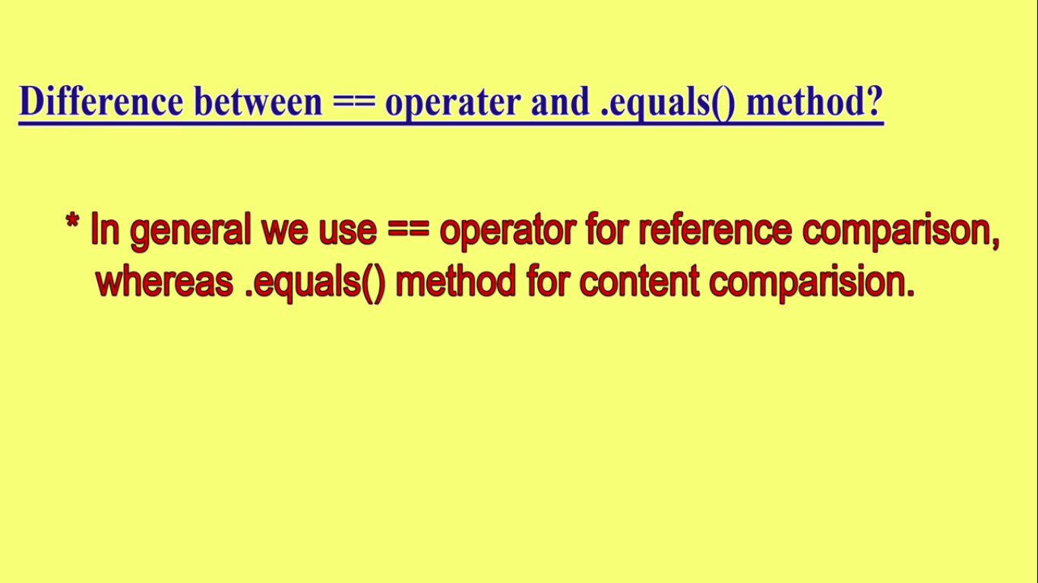

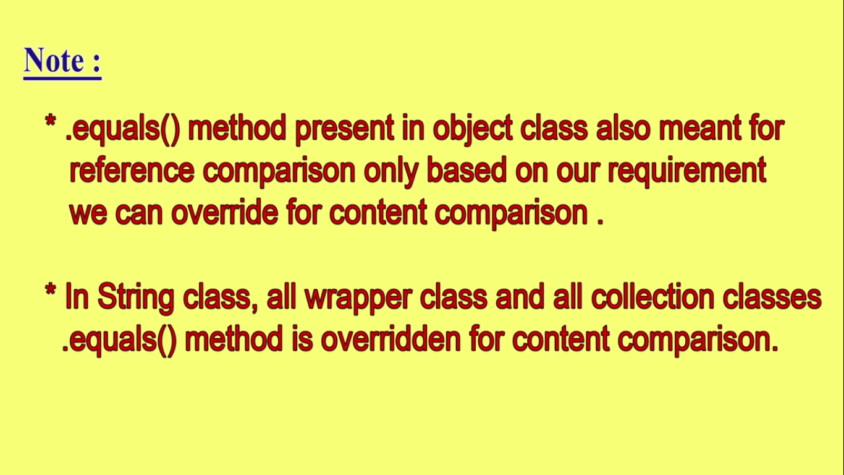

**How System.out.println works:**

System is class and out is static variable and which returns PrintStream object and println is method of PrintStream class.

**Difference between Comparable and Comparator**

1) Comparator in Java is defined in java.util package while Comparable interface in Java is defined in java.lang package, which very much says that Comparator should be used as an utility to sort objects which Comparable should be provided by default.

2) Comparator interface in Java has method public int compare (Object o1, Object o2) which returns a negative integer, zero, or a positive integer as the first argument is less than, equal to, or greater than the second. While Comparable interface has method public int compareTo(Object o) which returns a negative integer, zero, or a positive integer as this object is less than, equal to, or greater than the specified object.

3) If you see then logical difference between these two is *Comparator in Java* compare two objects provided to him, while Comparable interface compares "this" reference with the object specified. I have shared lot of tips on [how to override compareTo() method](http://javarevisited.blogspot.sg/2011/11/how-to-override-compareto-method-in.html) and avoid some common mistakes programmer makes while implementing Comparable interface.

4) Comparable in Java is used to implement **natural ordering of object**. In Java API String, Date and wrapper classes implements Comparable interface.Its always good practice to override compareTo() for value objects.

5) If any class implement Comparable interface in Java then collection of that object either [List](http://javarevisited.blogspot.sg/2012/04/difference-between-list-and-set-in-java.html) or Array can be sorted automatically by using  Collections.sort() or Arrays.sort() method and object will be sorted based on there natural order defined by CompareTo method.

6)Objects which implement *Comparable in Java*  can be used as keys in a SortedMap like [TreeMap](http://javarevisited.blogspot.sg/2011/12/treemap-java-tutorial-example-program.html) or elements in a SortedSet  for example TreeSet, without specifying any Comparator.

These were combination of some theoretical and practical differences between Comparator and Comparator interface in Java. It does help you to decide when to use Comparator vs Comparable but things will be more clear when we some best practices around using both of these interfaces. Now let’s see an example of Comparator in Java

|  |  |  |
| --- | --- | --- |
| **Parameter** | **Comparable** | **Comparator** |
| Sorting logic | Sorting logic must be in same class whose objects are being sorted. Hence this is called natural ordering of objects | Sorting logic is in separate class. Hence we can  write different sorting based on different attributes  of objects to be sorted.  E.g. Sorting using id,name etc. |
| Implementation | Class whose objects to be sorted must implement this interface.e.g Country class needs to implement comparable to collection of country object by id | Class whose objects to be sorted do not need to  implement this interface.Some other class can implement this interface. E.g.-CountrySortByIdComparator class can implement Comparator interface to sort collection of country object by id |
| Sorting method | int compareTo(Object o1) This method compares this object with o1 object and returns a integer.Its value has following meaning 1. positive – this object is greater than o1 2. zero – this object equals to o1 3. negative – this object is less than o1 | int compare(Object o1,Object o2) This method compares o1 and o2 objects. and returns a integer.Its value has following meaning. 1. positive – o1 is greater than o2 2. zero – o1 equals to o2 3. negative – o1 is less than o1 |
| Calling method | Collections.sort(List) Here objects will be sorted on the basis of CompareTo method | Collections.sort(List, Comparator) Here objects will be sorted on the basis of Compare method in Comparator |
| Package | Java.lang.Comparable | Java.util.Comparator |

 in most real life scenarios, we want sorting based on different parameters. For example, as a CEO, I would like to sort the employees based on Salary, an HR would like to sort them based on the age. This is the situation where we need to use Comparator interface because Comparable.compareTo(Object o) method implementation can sort based on one field only and we can’t chose the field on which we want to sort the Object.

Comparator interface compare(Object o1, Object o2) method need to be implemented that takes two Object argument, it should be implemented in such a way that it returns negative int if first argument is less than the second one and returns zero if they are equal and positive int if first argument is greater than second one.

Collections.sort(list) to sort the list in ascending order and Collections.reverse(list) to sort reverse order. You can also use Collections.sort(list, Collections.revreserOrder()); which gives the reverse order. Same for arrays Array.sort(array, Collections.reverseOrder());

Collections.reverserOrder() return the comparator object which will take care to reverse the order.  
  
Read more: <http://javarevisited.blogspot.com/2011/06/comparator-and-comparable-in-java.html#ixzz3e3AFnZz6>

|  |  |
| --- | --- |
| **Comparable** | **Comparator** |
| 1) Comparable provides **single sorting sequence**. In other words, we can sort the collection on the basis of single element such as id or name or price etc. | Comparator provides **multiple sorting sequence**. In other words, we can sort the collection on the basis of multiple elements such as id, name and price etc. |
| 2) Comparable **affects the original class** i.e. actual class is modified. | Comparator **doesn't affect the original class** i.e. actual class is not modified. |
| 3) Comparable provides **compareTo() method** to sort elements. | Comparator provides **compare() method** to sort elements. |
| 4) Comparable is found in **java.lang** package. | Comparator is found in **java.util** package. |
| 5) We can sort the list elements of Comparable type by**Collections.sort(List)** method. | We can sort the list elements of Comparator type by**Collections.sort(List,Comparator)** method. |

**Exception Handling**

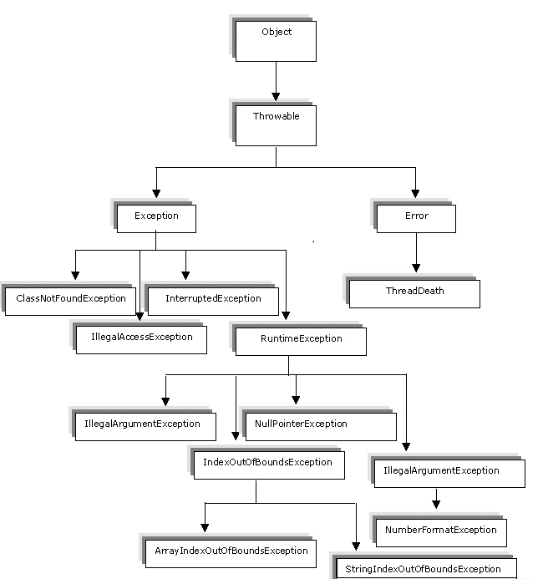

### 1) Checked Exception

The classes that extend Throwable class except RuntimeException and Error are known as checked exceptions e.g.IOException, SQLException etc. Checked exceptions are checked at compile-time.

### 2) Unchecked Exception

The classes that extend RuntimeException are known as unchecked exceptions e.g. ArithmeticException, NullPointerException, ArrayIndexOutOfBoundsException etc. Unchecked exceptions are not checked at compile-time rather they are checked at runtime.

### 3) Error

Error is irrecoverable e.g. OutOfMemoryError, VirtualMachineError, AssertionError etc.

1. **int** a=50/0;//ArithmeticException
2. String s=**null**;

System.out.println(s.length());//NullPointerException

1. String s="abc";

**int** i=Integer.parseInt(s);//NumberFormatException

1. **int** a[]=**new** **int**[5];

a[10]=50; //ArrayIndexOutOfBoundsException

## Syntax of Nested try Catch

....

//Main try block

try

{

statement 1;

statement 2;

//try-catch block inside another try block

try

{

statement 3;

statement 4;

}

catch(Exception e1)

{

//Exception Message

}

//try-catch block inside another try block

try

{

statement 5;

statement 6;

}

catch(Exception e2)

{

//Exception Message

}

}

catch(Exception e3) //Catch of Main(parent) try block

{

//Exception Message

}

....

We can have multiple catch block for one try block but we cannot have multiple finally block for one try. Also we can have try{} catch(){} or try {}finally{} we can have try and finally combination without catch block. If you have multiple catch block then most generic exception should come at last. Like we cannot have catch(SQLException e) and then catch(Exception e)

If we have try catch finally combination then finally block should come after catch block only. If we have try block and then finally block and then catch block at the end then complier gives the error.

**Difference between throw and throws keyword**

|  |  |  |
| --- | --- | --- |
| **No.** | **throw** | **throws** |
| 1) | Java throw keyword is used to explicitly throw an exception. | Java throws keyword is used to declare an exception. |
| 2) | Checked exception cannot be propagated using throw only. | Checked exception can be propagated with throws. |
| 3) | Throw is followed by an instance. | Throws is followed by class. |
| 4) | Throw is used within the method. | Throws is used with the method signature. |
| 5) | You cannot throw multiple exceptions. | You can declare multiple exceptions e.g. public void method()throws IOException,SQLException. |

When you throw any exception in childclass method and your parent class method is not defined any exception in method signature in case of overriding then complier gives the error.

public String method1(String abc, String def) throws Exception{

System.out.println("method1 in subclass ");

throw new SQLException ("");} the above code is valid, if you define Exception class in method signature and you are throwing its child class. Reverse is not possible. And if you are calling method1 from any other method which has not defined throws class in method signature then also complier will give the error. Either you should define throws in method signature or you should surround with try catch while calling.

In method overloading Exception handling doesn’t matter. (in one method you can have throws Exception and there is not necessary to be define same in other method also)

If you throw any Exception using throw keyword in method and if throws is not defined in the method signature then complier will give error. Otherwise you have to surround with try catch the throw inside the method. If you are reading any file for processing and if you don’t find that particular file then you can throw FileNotFoundException(); like if(filenotfound) { throw FileNotFoundException(); }

**User defined Exception**

class WrongInputException extends Exception {

WrongInputException(String s) {

super(s);

}

}

class Input {

void method() throws WrongInputException {

throw new WrongInputException("Wrong input");

}

}

class TestInput {

public static void main(String[] args){

try {

new Input().method();

}

catch(WrongInputException wie) {

System.out.println(wie.getMessage());

}

}

}

**JAVA JDBC**

* **DriverManager**: Manages a list of database drivers. Matches connection requests from the java application with the proper database driver using communication subprotocol. The first driver that recognizes a certain subprotocol under JDBC will be used to establish a database Connection.
* **Driver**: The database communications link, handling all communication with the database. Normally, once the driver is loaded, the developer need not call it explicitly.
* **Connection**: Interface with all methods for contacting a database.The connection object represents communication context, i.e., all communication with database is through connection object only.
* **Statement** : Encapsulates an SQL statement which is passed to the database to be parsed, compiled, planned and executed.
* **ResultSet**: The ResultSet represents set of rows retrieved due to query execution.

**Statement**

Statement acts like a vehicle through which SQL commands can be sent. Through the connection object we create statement kind of objects.  
Through the connection object we create statement kind of objects.

Statement stmt = conn.createStatement();

This method returns object which implements statement interface.

**PreparedStatement**

A prepared statement is an SQL statement that is precompiled by the database. Through precompilation, prepared statements improve the performance of SQL commands that are executed multiple times (given that the database supports prepared statements). Once compiled, prepared statements can be customized prior to each execution by altering predefined SQL parameters.

PreparedStatement pstmt = conn.prepareStatement("UPDATE EMPLOYEES SET SALARY = ? WHERE ID = ?");

pstmt.setBigDecimal(1, 153833.00);

pstmt.setInt(2, 110592);

Here:connis an instance of the Connection class and"**?**"represents parameters.These parameters must be specified before execution.

|  |  |
| --- | --- |
| **Statement** | **PreparedStatement** |
| A standard Statement is used to create a Java representation of a literal SQL statement and execute it on the database. | A PreparedStatement is a precompiled  statement. This means that when  the PreparedStatement is executed, the RDBMS can just run the  PreparedStatement SQL statement without having to compile it first. |
| Statement has to verify its metadata against the database every time. | While a prepared statement has to verify its metadata against the  database only once. |
| If you want to execute the SQL statement once go for STATEMENT | If you want to execute a single SQL statement multiple number of times,  then go for PREPAREDSTATEMENT. PreparedStatement objects can be reused  with passing different values to the queries |

**How to call a stored procedure from JDBC ?**

PL/SQL stored procedures are called from within JDBC programs by means of the prepareCall() method of the Connection object created. A call to this method takes variable bind parameters as input parameters as well as output variables and creates an object instance of the CallableStatement class.

The following line of code illustrates this:

CallableStatement stproc\_stmt = conn.prepareCall("{call procname(?,?,?)}");

Here conn is an instance of the Connection class.

**What are the types of resultsets?**

The values are defined in the class java.sql.Connection and are:

* TYPE\_FORWARD\_ONLY specifies that a resultset is not scrollable, that is, rows within it can be advanced only in the forward direction.
* TYPE\_SCROLL\_INSENSITIVE specifies that a resultset is scrollable in either direction but is insensitive to changes committed by other transactions or other statements in the same transaction.
* TYPE\_SCROLL\_SENSITIVE specifies that a resultset is scrollable in either direction and is affected by changes committed by other transactions or statements within the same transaction.

***Note****:*A TYPE\_FORWARD\_ONLY*resultset is always insensitive.*

|  |  |
| --- | --- |
| public int executeUpdate() | executes the query. It is used for create, drop, insert, update, delete etc. |
| public ResultSet executeQuery() | executes the select query. It returns an instance of ResultSet. |

### Commonly used methods of Connection interface:

|  |
| --- |
| **1) public Statement createStatement():** creates a statement object that can be used to execute SQL queries. |
| **2) public Statement createStatement(int resultSetType,int resultSetConcurrency):** Creates a Statement object that will generate ResultSet objects with the given type and concurrency. |
| **3) public void setAutoCommit(boolean status):** is used to set the commit status.By default it is true. |
| **4) public void commit():** saves the changes made since the previous commit/rollback permanent. |
| **5) public void rollback():** Drops all changes made since the previous commit/rollback. |
| **6) public void close():** closes the connection and Releases a JDBC resources immediately. |

**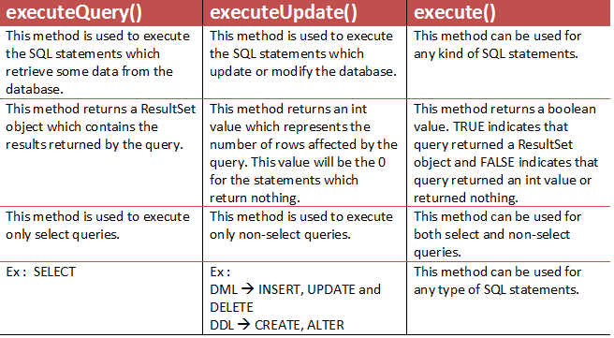**

**Multithreading**

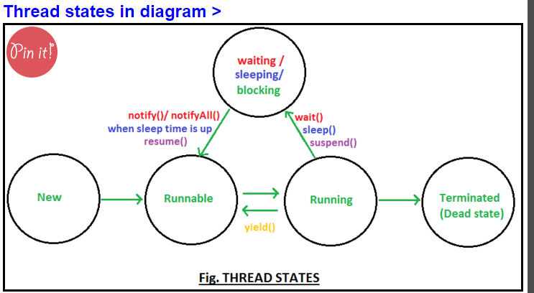

* Thread scheduler is a part of JVM. It is responsible to schedule threads.

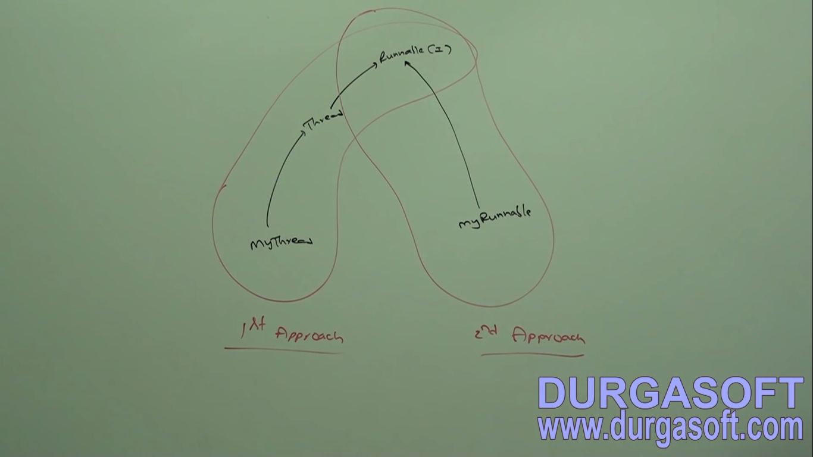

Runnable interface present in java.lang package and it contains only method run method.

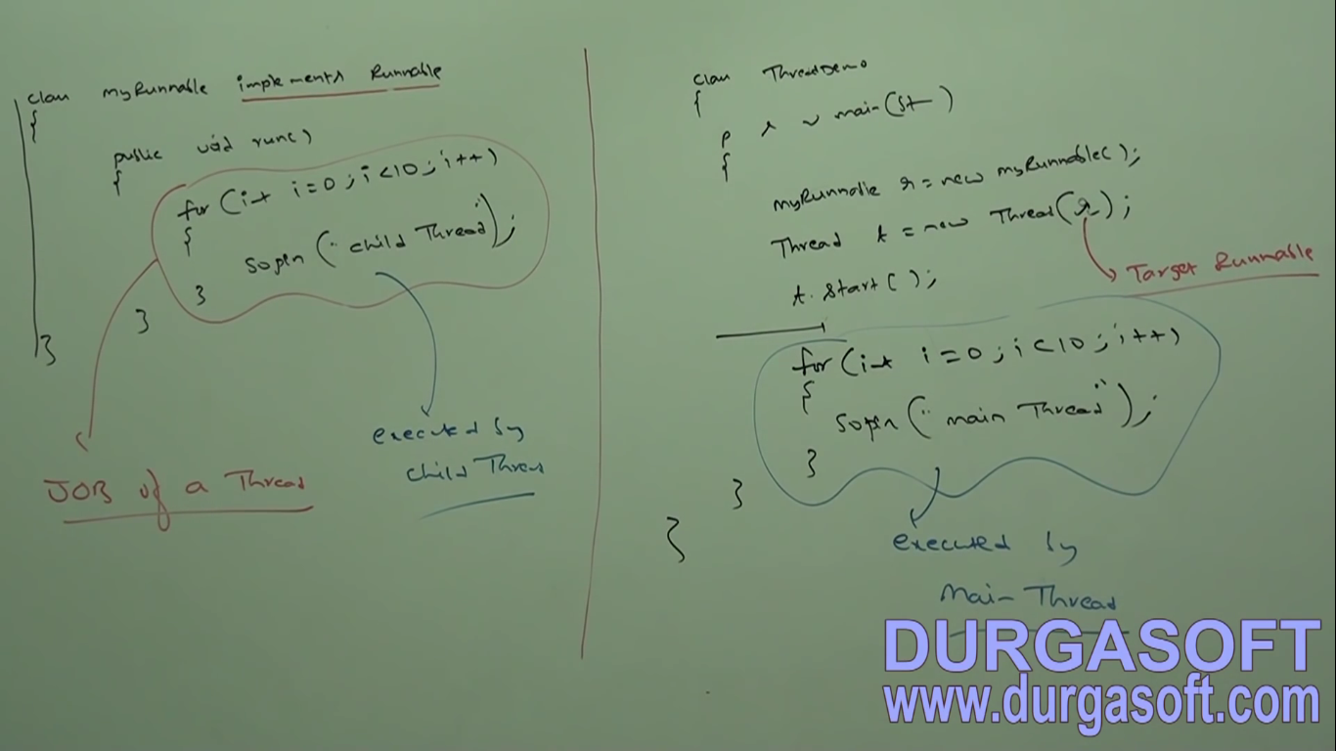

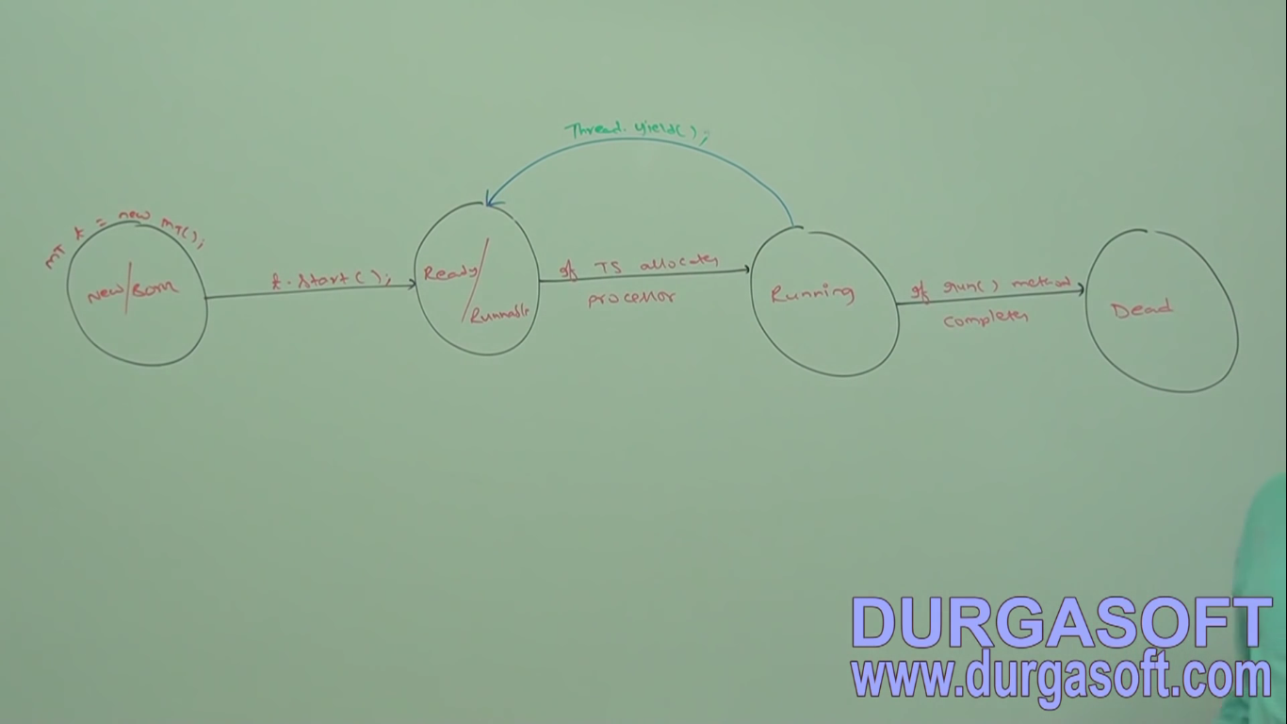

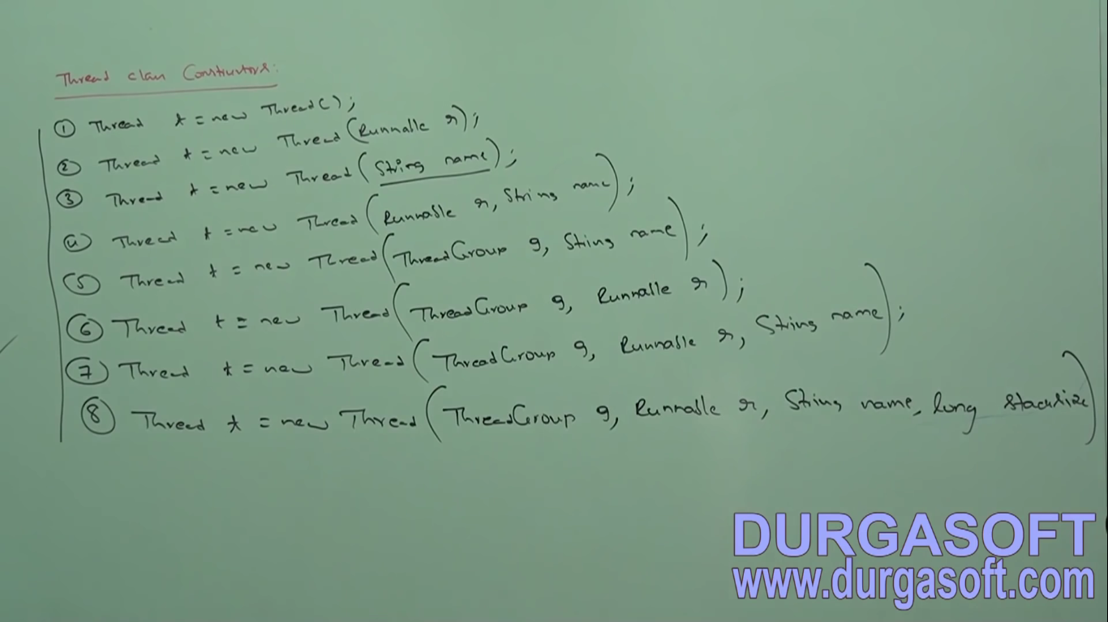

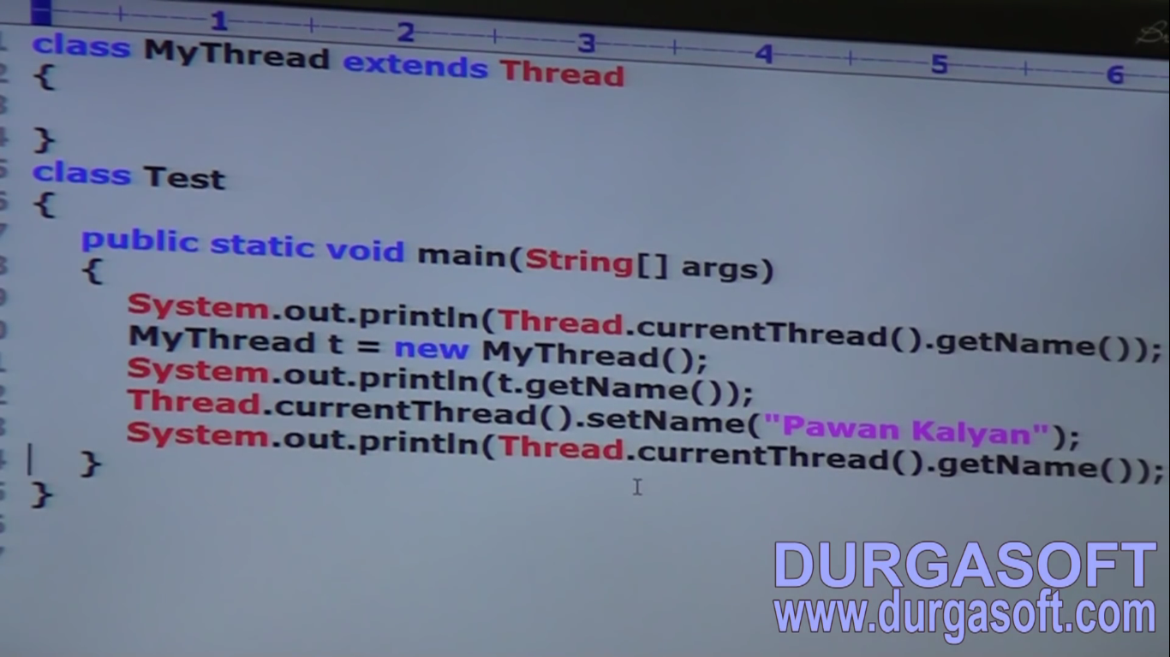

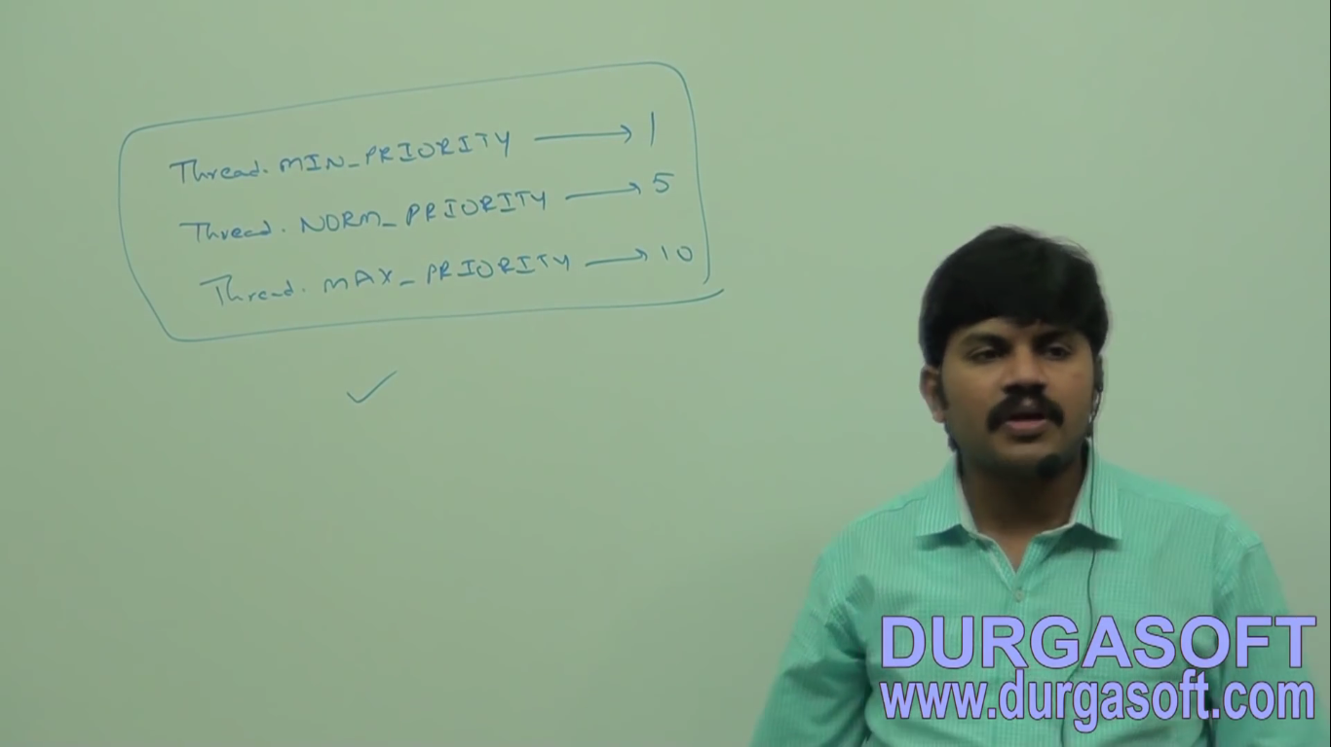

* Thread with highest priority will get the chance first.
* Thread with same priority execution depends on thread scheduler.

There are 3 ways to prevent the execution of thread temporarily.

* 1. In join method threads wait till completion of other thread which it joins.
  2. In yield method causes the currently executing thread object to temporarily pause and allow other threads to execute.
  3. The sleep() method of Thread class is used to sleep a thread for the specified amount of time.

# Sleep method in java

The sleep() method of Thread class is used to sleep a thread for the specified amount of time.

## Syntax of sleep() method in java

The Thread class provides two methods for sleeping a thread:

* public static void sleep(long miliseconds)throws InterruptedException
* public static void sleep(long miliseconds, int nanos)throws InterruptedException

## Example of sleep method in java

1. **class** TestSleepMethod1 **extends** Thread{
2. **public** **void** run(){
3. **for**(**int** i=1;i<5;i++){
4. **try**{Thread.sleep(500);}**catch**(InterruptedException e){System.out.println(e);}
5. System.out.println(i);
6. }
7. }
8. **public** **static** **void** main(String args[]){
9. TestSleepMethod1 t1=**new** TestSleepMethod1();
10. TestSleepMethod1 t2=**new** TestSleepMethod1();
12. t1.start();
13. t2.start();
14. }
15. }

# Can we start a thread twice

No. After starting a thread, it can never be started again. If you does so, an IllegalThreadStateException is thrown. In such case, thread will run once but for second time, it will throw exception.

Let's understand it by the example given below:

1. **public** **class** TestThreadTwice1 **extends** Thread{
2. **public** **void** run(){
3. System.out.println("running...");
4. }
5. **public** **static** **void** main(String args[]){
6. TestThreadTwice1 t1=**new** TestThreadTwice1();
7. t1.start();
8. t1.start();
9. }
10. }

[**Test it Now**](http://www.javatpoint.com/opr/test.jsp?filename=TestThreadTwice1)

running

Exception in thread "main" java.lang.IllegalThreadStateException

**Main Thread deadlock**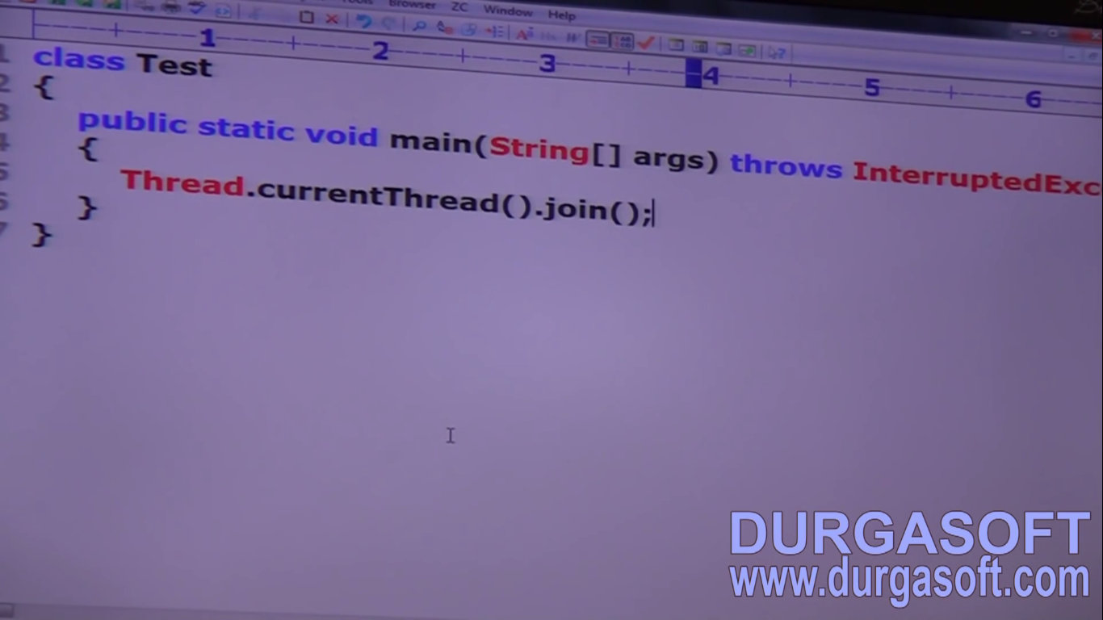

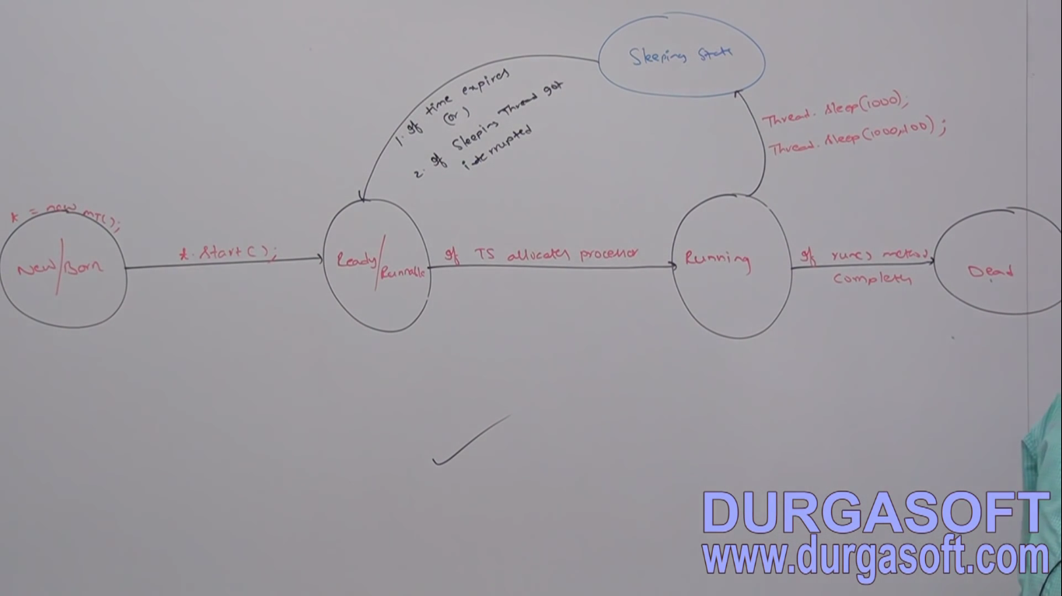

Thread can interrupt a sleeping thread or waiting thread by using interrupt method of thread class,

Public void interrupt()

{

}

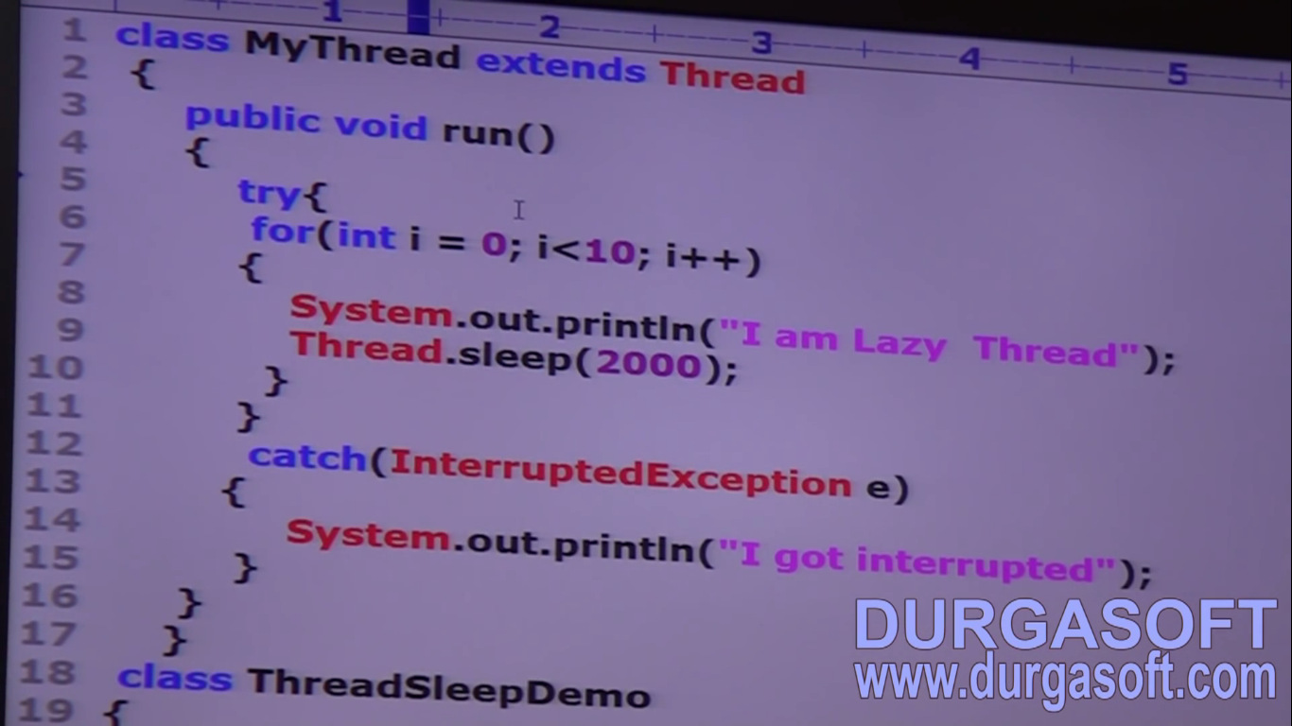

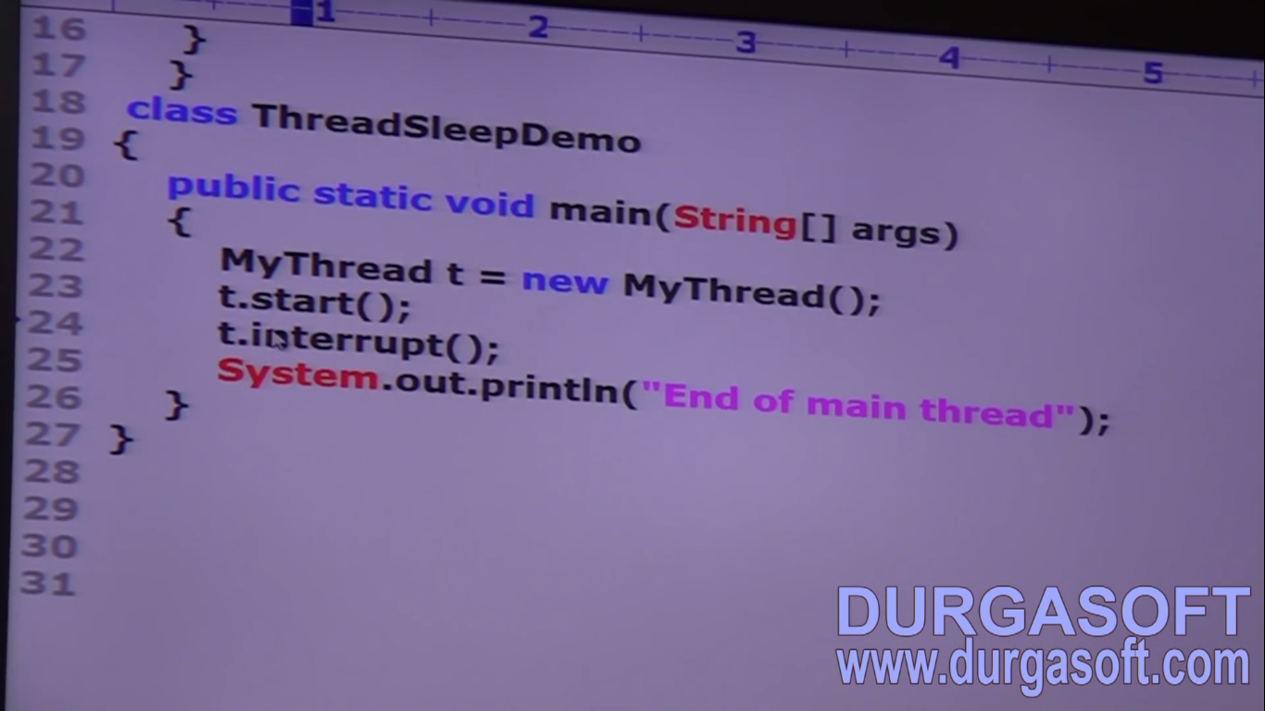

If the target thread is not in sleep or waiting state then there is no impact interrupt method. It will wait till the target thread goes in sleep state ,this is taken care by jvm.

Interrupt call is wasted only when the target thread never enters in sleeping state.

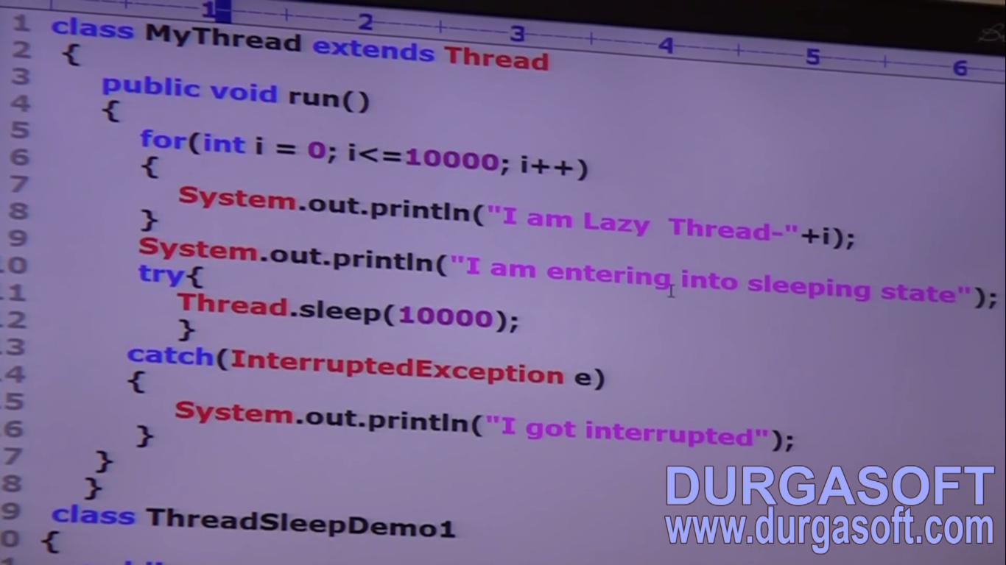

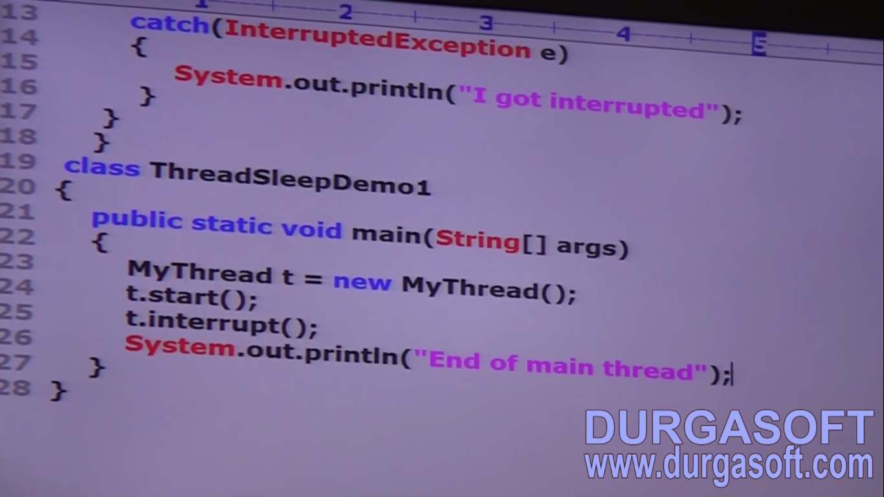

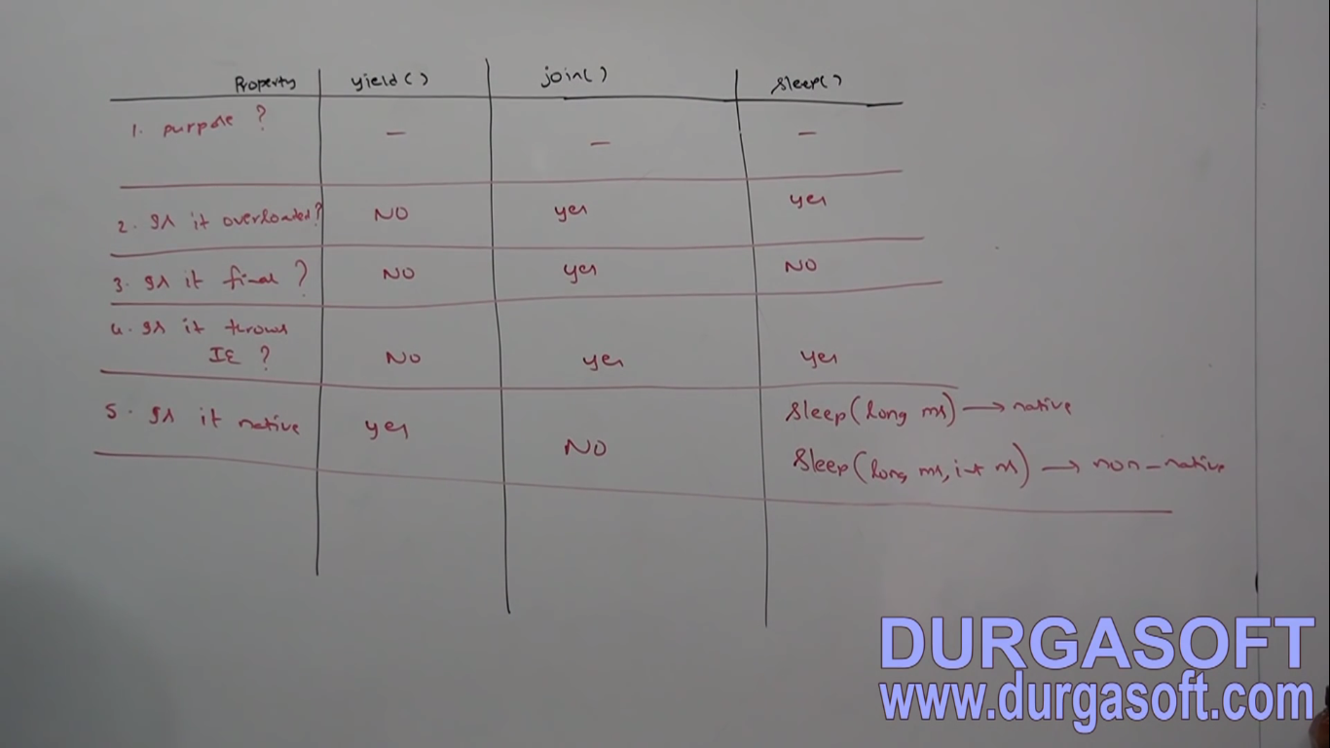

# Synchronization in Java

Synchronization in java is the capability to control the access of multiple threads to any shared resource.

Java Synchronization is better option where we want to allow only one thread to access the shared resource.

### Why use Synchronization

The synchronization is mainly used to

1. To prevent thread interference.
2. To prevent consistency problem.

### Types of Synchronization

There are two types of synchronization

1. Process Synchronization
2. Thread Synchronization

Here, we will discuss only thread synchronization.

### Thread Synchronization

There are two types of thread synchronization mutual exclusive and inter-thread communication.

1. Mutual Exclusive
   1. Synchronized method.
   2. Synchronized block.
   3. static synchronization.
2. Cooperation (Inter-thread communication in java)

### Mutual Exclusive

Mutual Exclusive helps keep threads from interfering with one another while sharing data. This can be done by three ways in java:

1. by synchronized method
2. by synchronized block
3. by static synchronization

### Concept of Lock in Java

Synchronization is built around an internal entity known as the lock or monitor. Every object has an lock associated with it. By convention, a thread that needs consistent access to an object's fields has to acquire the object's lock before accessing them, and then release the lock when it's done with them.

From Java 5 the package java.util.concurrent.locks contains several lock implementations.

### Understanding the problem without Synchronization

In this example, there is no synchronization, so output is inconsistent. Let's see the example:

1. Class Table{
3. **void** printTable(**int** n){//method not synchronized
4. **for**(**int** i=1;i<=5;i++){
5. System.out.println(n\*i);
6. **try**{
7. Thread.sleep(400);
8. }**catch**(Exception e){System.out.println(e);}
9. }
11. }
12. }
14. **class** MyThread1 **extends** Thread{
15. Table t;
16. MyThread1(Table t){
17. **this**.t=t;
18. }
19. **public** **void** run(){
20. t.printTable(5);
21. }
23. }
24. **class** MyThread2 **extends** Thread{
25. Table t;
26. MyThread2(Table t){
27. **this**.t=t;
28. }
29. **public** **void** run(){
30. t.printTable(100);
31. }
32. }
34. **class** TestSynchronization1{
35. **public** **static** **void** main(String args[]){
36. Table obj = **new** Table();//only one object
37. MyThread1 t1=**new** MyThread1(obj);
38. MyThread2 t2=**new** MyThread2(obj);
39. t1.start();
40. t2.start();
41. }
42. }

Output: 5

100

10

200

15

300

20

400

25

500

### Java synchronized method

If you declare any method as synchronized, it is known as synchronized method.

Synchronized method is used to lock an object for any shared resource.

When a thread invokes a synchronized method, it automatically acquires the lock for that object and releases it when the thread completes its task.

1. //example of java synchronized method
2. **class** Table{
3. **synchronized** **void** printTable(**int** n){//synchronized method
4. **for**(**int** i=1;i<=5;i++){
5. System.out.println(n\*i);
6. **try**{
7. Thread.sleep(400);
8. }**catch**(Exception e){System.out.println(e);}
9. }
11. }
12. }
14. **class** MyThread1 **extends** Thread{
15. Table t;
16. MyThread1(Table t){
17. **this**.t=t;
18. }
19. **public** **void** run(){
20. t.printTable(5);
21. }
23. }
24. **class** MyThread2 **extends** Thread{
25. Table t;
26. MyThread2(Table t){
27. **this**.t=t;
28. }
29. **public** **void** run(){
30. t.printTable(100);
31. }
32. }
34. **public** **class** TestSynchronization2{
35. **public** **static** **void** main(String args[]){
36. Table obj = **new** Table();//only one object
37. MyThread1 t1=**new** MyThread1(obj);
38. MyThread2 t2=**new** MyThread2(obj);
39. t1.start();
40. t2.start();
41. }
42. }

Output: 5

10

15

20

25

100

200

300

400

500

### Example of synchronized method by using annonymous class

In this program, we have created the two threads by annonymous class, so less coding is required.

1. //Program of synchronized method by using annonymous class
2. **class** Table{
3. **synchronized** **void** printTable(**int** n){//synchronized method
4. **for**(**int** i=1;i<=5;i++){
5. System.out.println(n\*i);
6. **try**{
7. Thread.sleep(400);
8. }**catch**(Exception e){System.out.println(e);}
9. }
11. }
12. }
14. **public** **class** TestSynchronization3{
15. **public** **static** **void** main(String args[]){
16. **final** Table obj = **new** Table();//only one object
18. Thread t1=**new** Thread(){
19. **public** **void** run(){
20. obj.printTable(5);
21. }
22. };
23. Thread t2=**new** Thread(){
24. **public** **void** run(){
25. obj.printTable(100);
26. }
27. };
29. t1.start();
30. t2.start();
31. }
32. }

Output: 5

10

15

20

25

100

200

300

400

500

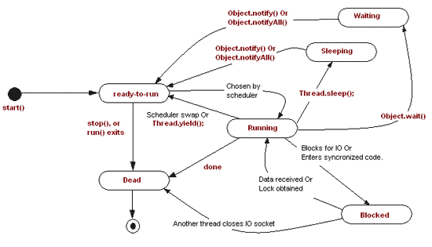

|  |  |
| --- | --- |
|  |  |

|  |  |  |  |  |  |  |  |  |  |  |
| --- | --- | --- | --- | --- | --- | --- | --- | --- | --- | --- |
|  | Daemon Thread in Java **Daemon thread in java** is a service provider thread that provides services to the user thread. Its life depend on the mercy of user threads i.e. when all the user threads dies, JVM terminates this thread automatically.  There are many java daemon threads running automatically e.g. gc, finalizer etc.  You can see all the detail by typing the jconsole in the command prompt. The jconsole tool provides information about the loaded classes, memory usage, running threads etc. Points to remember for Daemon Thread in Java  * It provides services to user threads for background supporting tasks. It has no role in life than to serve user threads. * Its life depends on user threads. * It is a low priority thread.  Why JVM terminates the daemon thread if there is no user thread? The sole purpose of the daemon thread is that it provides services to user thread for background supporting task. If there is no user thread, why should JVM keep running this thread. That is why JVM terminates the daemon thread if there is no user thread. Methods for Java Daemon thread by Thread class The java.lang.Thread class provides two methods for java daemon thread.   |  |  |  | | --- | --- | --- | | **No.** | **Method** | **Description** | | 1) | public void setDaemon(boolean status) | is used to mark the current thread as daemon thread or user thread. | | 2) | public boolean isDaemon() | is used to check that current is daemon. |  Simple example of Daemon thread in java *File: MyThread.java*   1. **public** **class** TestDaemonThread1 **extends** Thread{ 2. **public** **void** run(){ 3. **if**(Thread.currentThread().isDaemon()){//checking for daemon thread 4. System.out.println("daemon thread work"); 5. } 6. **else**{ 7. System.out.println("user thread work"); 8. } 9. } 10. **public** **static** **void** main(String[] args){ 11. TestDaemonThread1 t1=**new** TestDaemonThread1();//creating thread 12. TestDaemonThread1 t2=**new** TestDaemonThread1(); 13. TestDaemonThread1 t3=**new** TestDaemonThread1(); 15. t1.setDaemon(**true**);//now t1 is daemon thread 17. t1.start();//starting threads 18. t2.start(); 19. t3.start(); 20. } 21. }   [**Test it Now**](http://www.javatpoint.com/opr/test.jsp?filename=TestDaemonThread1) Output daemon thread work  user thread work  user thread work  Difference between Sleep () and Wait ():  sleep(): It is a static method on Thread class. It makes the current thread into the "Not Runnable" state for specified amount of time. During this time, the thread keeps the lock (monitors) it has acquired.  wait(): It is a method on Object class. It makes the current thread into the "Not Runnable" state. Wait is called on a object, not a thread. Before calling wait() method, the object should be synchronized, means the object should be inside synchronized block. The call to wait() releases the acquired lock.   1. yield() method pauses the currently executing thread temporarily for giving a chance to the remaining waiting threads of the same priority to execute. If there is no waiting thread or all the waiting threads have a lower priority then the same thread will continue its execution. The yielded thread when it will get the chance for execution is decided by the thread scheduler whose behavior is vendor dependent. 2. join() If any executing thread t1 calls join() on t2 i.e; t2.join() immediately t1 will enter into waiting state until t2 completes its execution. 3. sleep() Based on our requirement we can make a thread to be in sleeping state for a specified period of time (hope not much explanation required for our favorite method). |

**Volatile Keyword in Java**

The Java volatile keyword is used to mark a Java variable as "being stored in main memory". More precisely that means, that every read of a volatile variable will be read from the computer's main memory, and not from the CPU cache, and that every write to a volatile variable will be written to main memory, and not just to the CPU cache.

The Java volatile keyword guarantees visibility of changes to variables across threads.

In a multithreaded application where the threads operate on non-volatile variables, each thread may copy variables from main memory into a CPU cache while working on them, for performance reasons. If your computer contains more than one CPU, each thread may run on a different CPU. That means, that each thread may copy the variables into the CPU cache of different CPUs.

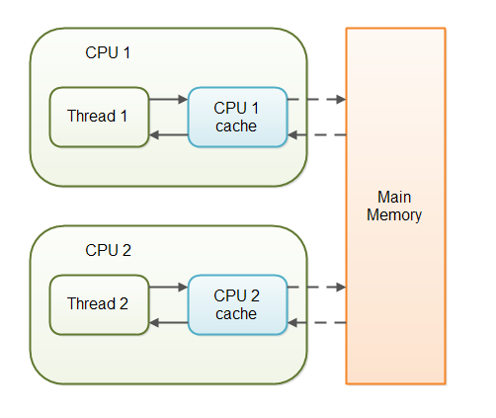

With non-volatile variables there are no guarantees about when the Java Virtual Machine (JVM) reads data from main memory into CPU caches, or writes data from CPU caches to main memory. Let me explain what problems that can cause with an example:

Imagine a situation in which two or more threads have access to a shared object which contains a counter variable declared like this:

public class SharedObject {

public int counter = 0;

}

Thread 1 could read a shared counter variable with the value 0 into its CPU cache, increment it to 1 and not write the changed value back into main memory. Thread 2 could then read the same counter variable from main memory where the value of the variable is still 0, into its own CPU cache. Thread 2 could then also increment the counter to 1, and also not write it back to main memory. Thread 1 and Thread 2 are now practically out of sync. The real value of the shared counter variable should have been 2, but each of the threads has the value 1 for the variable in their CPU caches, and in main memory the value is still 0. It is a mess! Even if the threads eventually write their value for the shared counter variable back to main memory, the value will be wrong.

By declaring the shared counter variable volatile the JVM guarantees that every read of the variable will always be read from main memory, and that all writes to the variable will always be written back to main memory. Here is how the volatile declaration looks:

public class SharedObject {

public **volatile** int counter = 0;

}

In some cases simply declaring a variable volatile may be enough to assure that multiple threads accessing the variable see the latest written value.

**Singleton Design Patter.**

The singleton class must provide a global access point to get the instance of the class. Singleton pattern is used for [logging](http://www.journaldev.com/977/java-logging-api-tutorial-examples-logger-levels-handlers-formatters-filters), drivers objects, caching and [thread pool](http://www.journaldev.com/1069/java-thread-pool-example-using-executors-and-threadpoolexecutor).

Problem:

* Instead of creating multiple objects of same class having same data and wasting memory, degrading performance it is recommended to create only one object and use it multiple times.

**Solution:**

* Use Singleton Java Class.
* Java class that allows us to create one object per JVM is called as singleton java class.
* The logger class of Log 4J API is given as singleton java class.

**Rules:**

* It must have only private constructors.
* It must have private static reference variable of same class.
* It must have public static factory method having the logic of singleton.
* Static method should create and return only one object.
* All these rules close all the doors of creating objects for java class and opens only one door to create object.
* factory method where singleton logic is placed
* The method of a class capable of creating and returning same class or other class object is known as factory method.

Example

2. public class SingletonClass {
3. private static SingletonClass object;
5. private SingletonClass ()
6. {
7. System.out.println("Singleton(): Private constructor invoked");
8. }
10. public static SingletonClass getInstance()
11. {
13. if (object == null)
14. {
16. System.out.println("getInstance(): First time getInstance was called and object created !");
17. object = new SingletonClass ();
19. }
20. return object;
22. }
23. }

|  |  |  |  |
| --- | --- | --- | --- |
| **No.** | **final** | **finally** | **Finalize** |
| 1) | Final is used to apply restrictions on class, method and variable. Final class can't be inherited, final method can't be overridden and final variable value can't be changed. | Finally is used to place important code, it will be executed whether exception is handled or not. | Finalize is used to perform clean up processing just before object is garbage collected. |
| 2) | Final is a keyword. | Finally is a block. | Finalize is a method. |

|  |  |  |
| --- | --- | --- |
| **No.** | **StringBuffer** | **StringBuilder** |
| 1) | StringBuffer is synchronized i.e. thread safe. It means two threads can't call the methods of StringBuffer simultaneously. | StringBuilder is non-synchronized i.e. not thread safe. It means two threads can call the methods of StringBuilder simultaneously. |
| 2) | StringBuffer is less efficient than StringBuilder. | StringBuilder is more efficient than StringBuffer. |

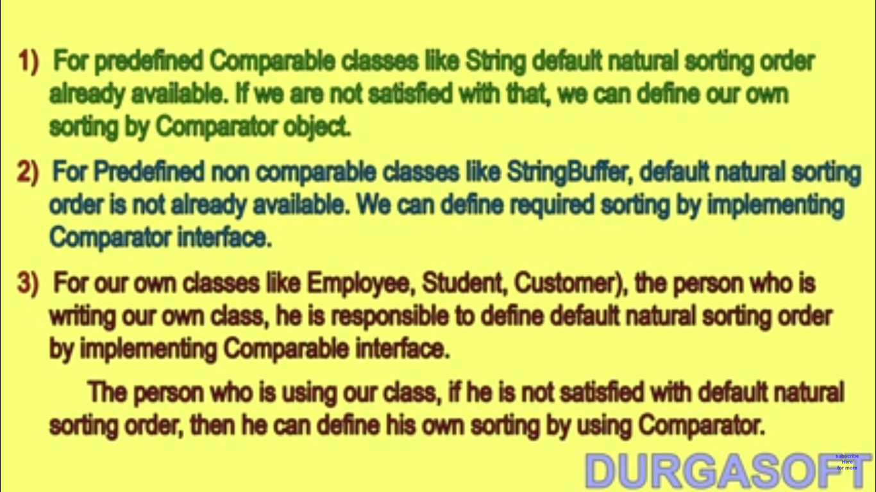

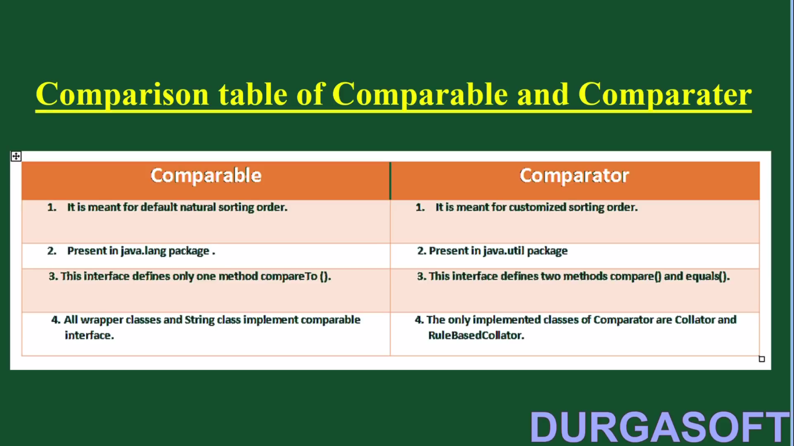

**Collections:**

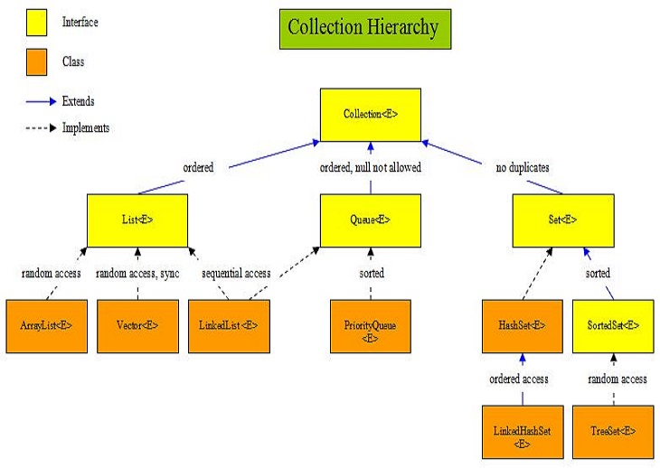

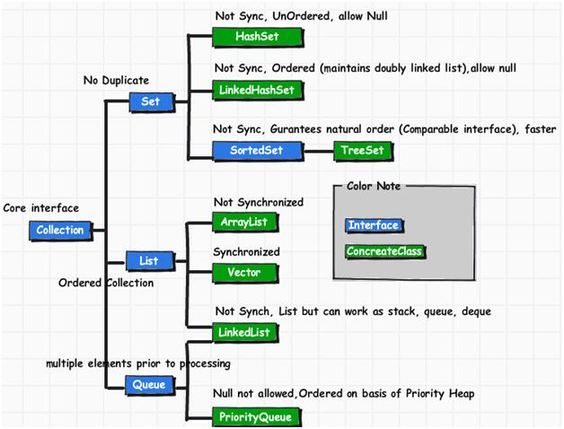

Default size of arraylist:10

Default size of Set:16

# Difference between ArrayList and LinkedList

|  |  |
| --- | --- |
| **ArrayList** | **LinkedList** |
| 1) ArrayList internally uses **dynamic array** to store the elements. | LinkedList internally uses **doubly linked list** to store the elements. |
| 2) Manipulation with ArrayList is **slow** because it internally uses array. If any element is removed from the array, all the bits are shifted in memory. | Manipulation with LinkedList is **faster** than ArrayList because it uses doubly linked list so no bit shifting is required in memory. |
| 3) ArrayList class can **act as a list** only because it implements List only. | LinkedList class can **act as a list and queue** both because it implements List and Deque interfaces. |
| 4) ArrayList is **better for storing and accessing** data. | LinkedList is **better for manipulating** data. |

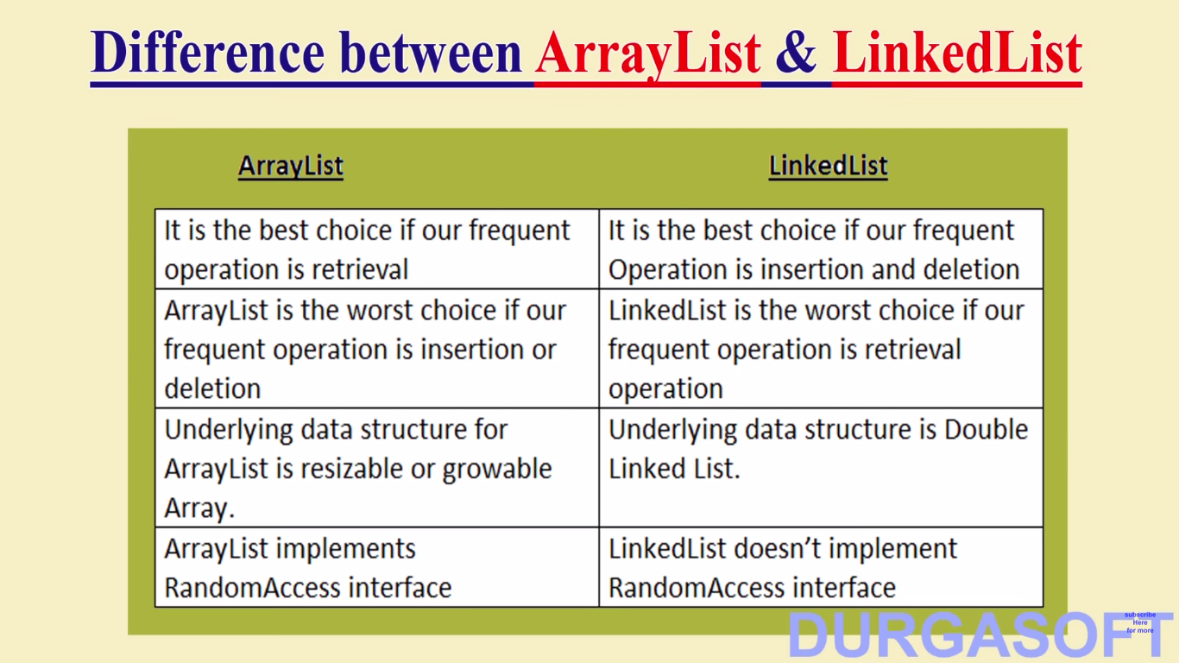

|  |  |
| --- | --- |
| **ArrayList** | **Vector** |
| 1) ArrayList is **not synchronized**. | Vector is **synchronized**. |
| 2) ArrayList **increments 50%** of current array size if number of element exceeds from its capacity. | Vector **increments 100%** means doubles the array size if total number of element exceeds than its capacity. |
| 3) ArrayList is **not a legacy** class, it is introduced in JDK 1.2. | Vector is a **legacy** class. |
| 4) ArrayList is **fast** because it is non-synchronized. | Vector is **slow** because it is synchronized i.e. in multithreading environment, it will hold the other threads in runnable or non-runnable state until current thread releases the lock of object. |
| 5) ArrayList uses **Iterator** interface to traverse the elements. | Vector uses **Enumeration** interface to traverse the elements. But it can use Iterator also. |

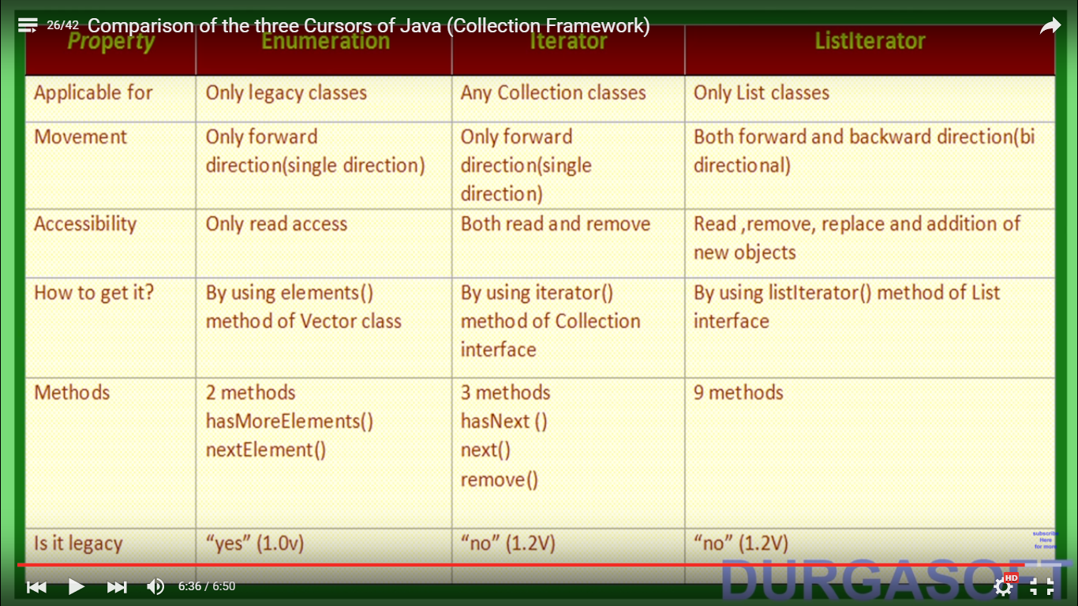

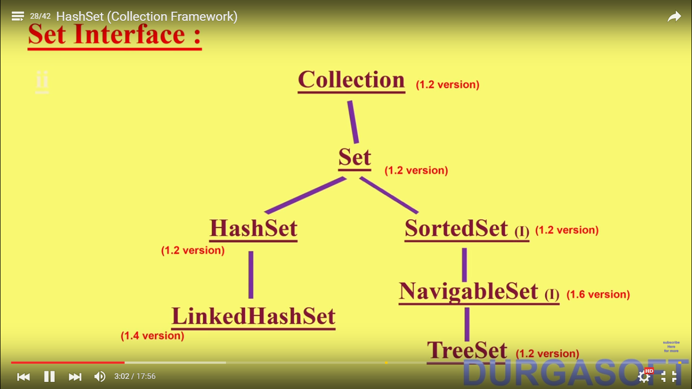

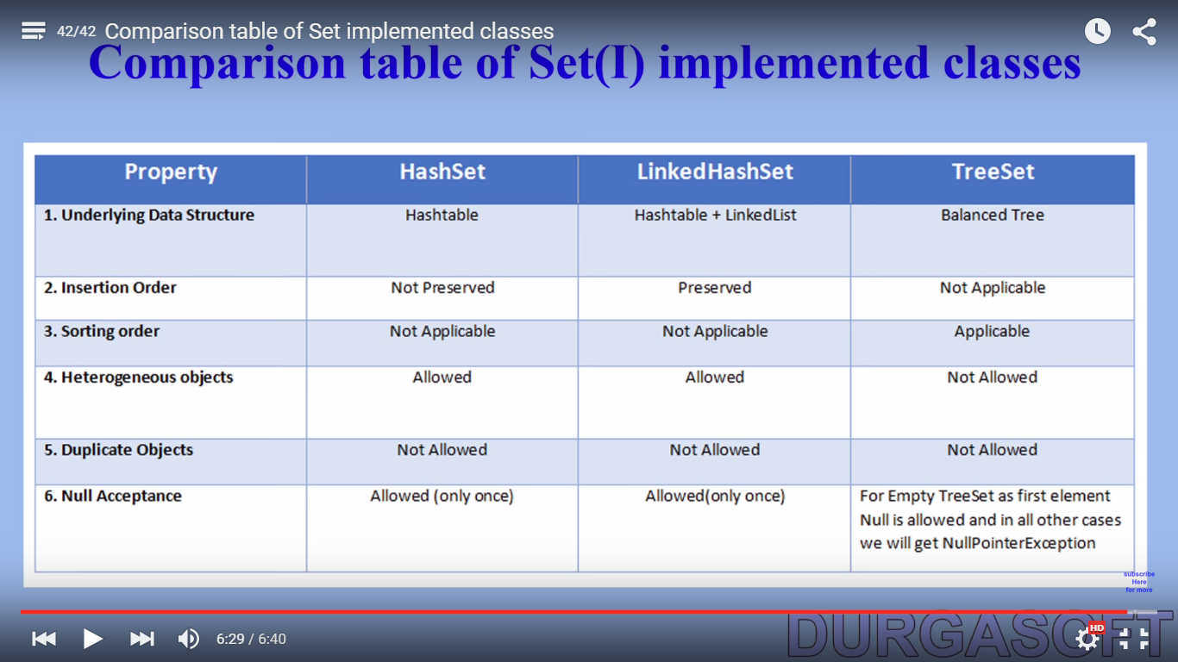

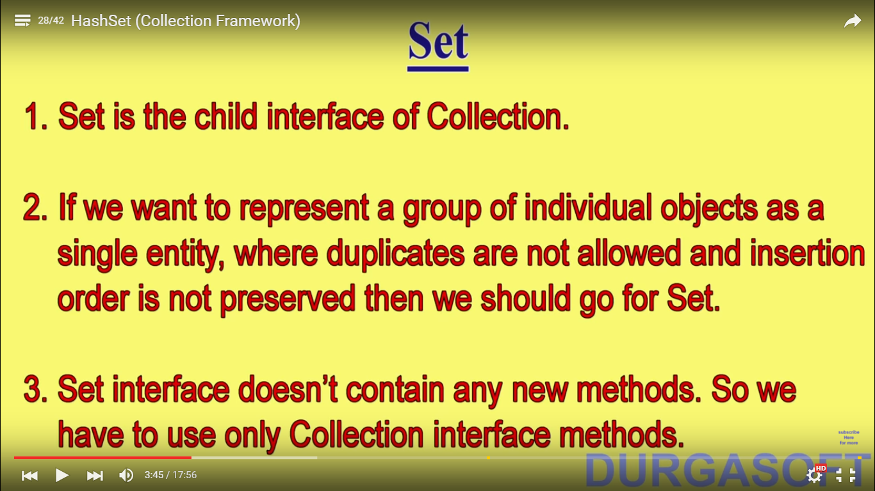

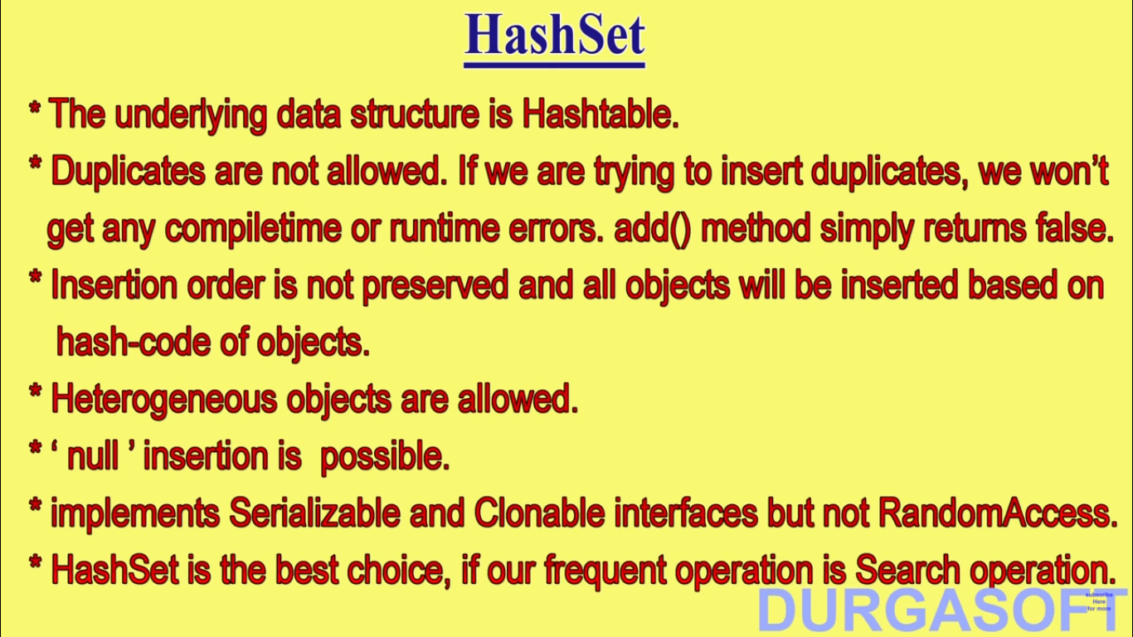

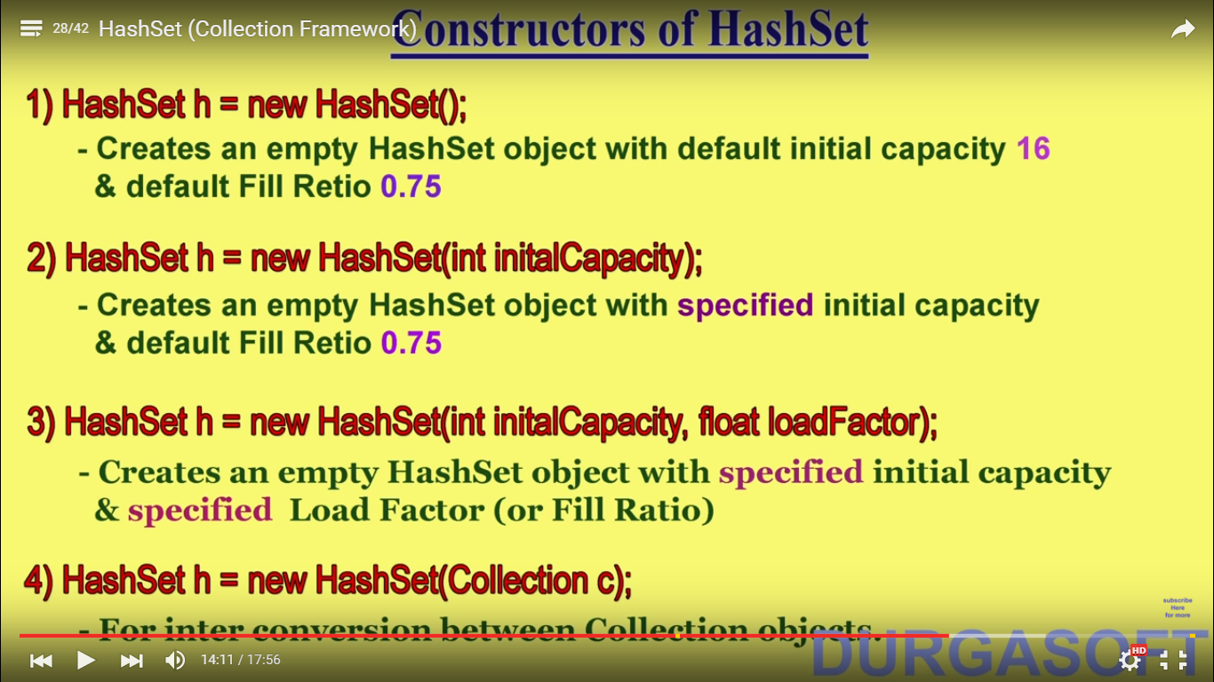

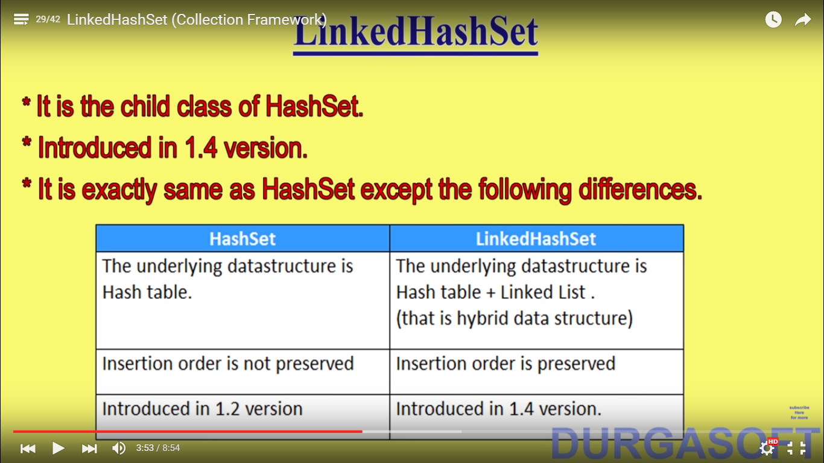

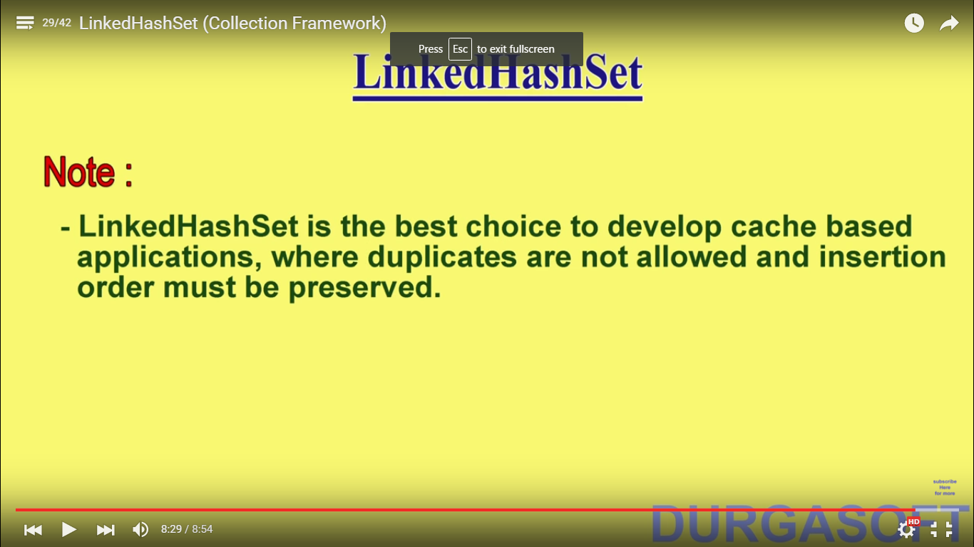

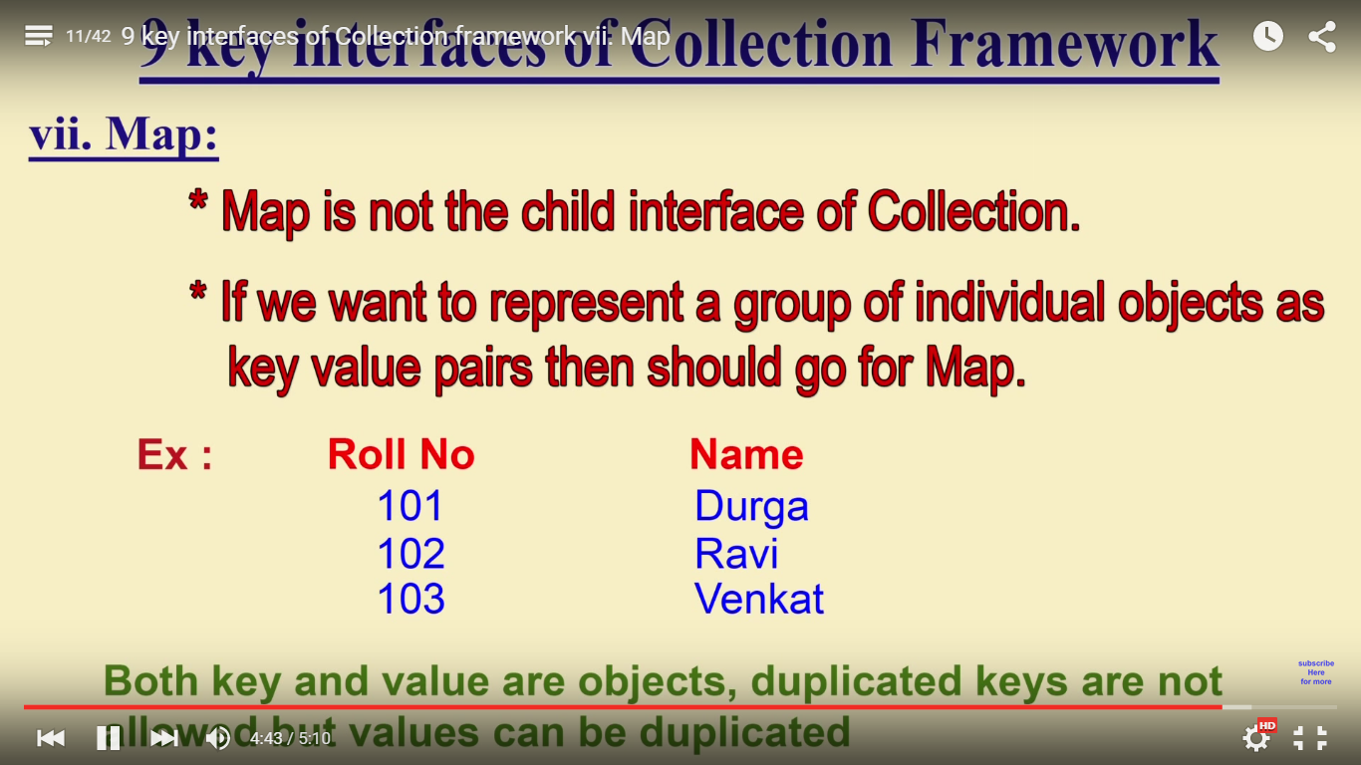

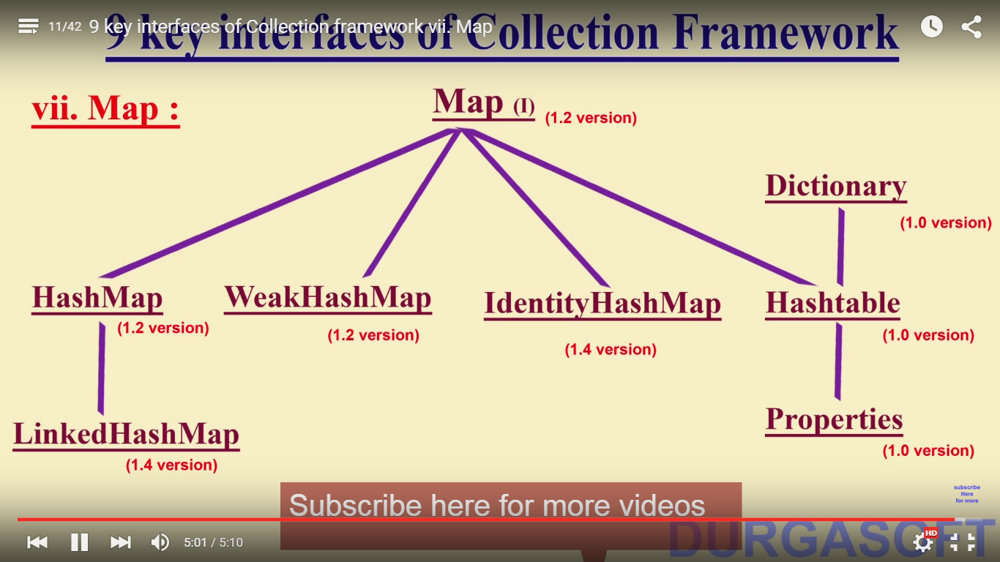

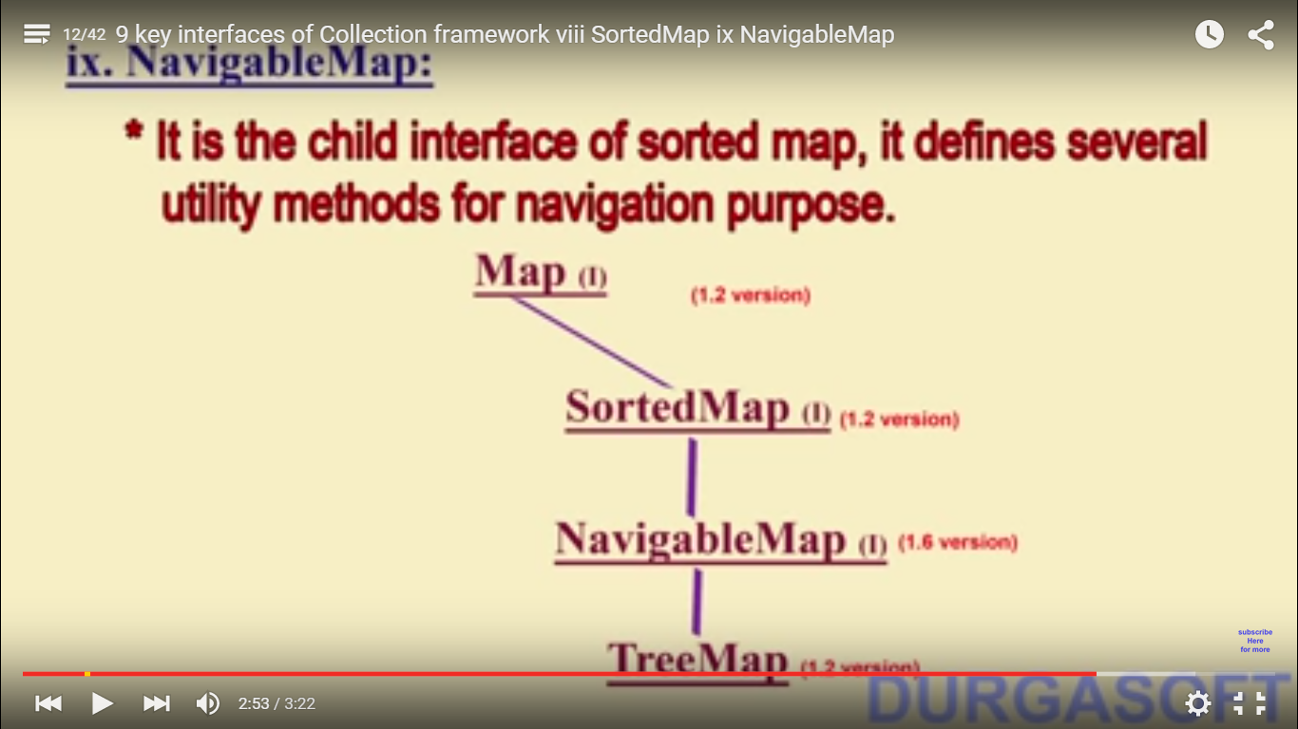

Whenever we create a hashset object it will create a hashmap object internally and adds the elements in it. Hashset.add method calls the hashmap.put method internally and it will put one dummy object as value for the key. If the key is duplicate then it will change its value for that corresponding key. Student s1= new Student(“abc”); Student s2= new Student(“abc”);

Hashset hs= new Hashset(); hs.add(s1); hs.add(s2); now if you print hs, it will have two objects because the hashcode for these objects are different.

If you add any user defined class or any class other than primitive classes (because all primitive classes implements Comparable interface) in Treeset or TreeMap then your class must implement Comparable interface or Comparator interface otherwise it will throw exception.

|  |  |
| --- | --- |
| **HashMap** | **Hashtable** |
| 1) HashMap is **non synchronized**. It is not-thread safe and can't be shared between many threads without proper synchronization code. | Hashtable is **synchronized**. It is thread-safe and can be shared with many threads. |
| 2) HashMap **allows one null key and multiple null values**. | Hashtable **doesn't allow any null key or value**. |
| 3) HashMap is a **new class introduced in JDK 1.2**. | Hashtable is a **legacy class**. |
| 4) HashMap is **fast**. | Hashtable is **slow**. |
| 5) We can make the HashMap as synchronized by calling this code Map m = Collections.synchronizedMap(hashMap); | Hashtable is internally synchronized and can't be unsynchronized. |
| 6) HashMap is **traversed by Iterator**. | Hashtable is **traversed by Enumerator and Iterator**. |
| 7) Iterator in HashMap is **fail-fast**. | Enumerator in Hashtable is **not fail-fast**. |
| 8) HashMap inherits **AbstractMap** class. | Hashtable inherits **Dictionary** class. |

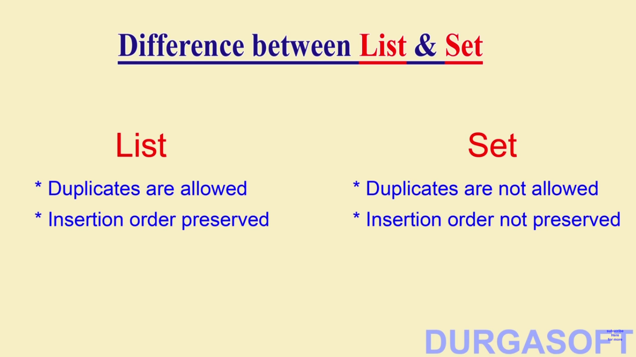

**HashMap vs ConcurrentHashMap**

**1.  Thread -Safe :**  
  
ConcurrentHashMap is thread-safe that is the code can be accessed by single thread at a time .      
     while HashMap is not thread-safe .  
  
**2.  Synchronization Method :**  
  
 HashMap can be synchronized by using      
    synchronizedMap(HashMap)  method .  By using this    
    method we get a HashMap object which is equivalent   
    to the HashTable object . So every modification  is performed      
    on  Map is locked on Map object.

**import** **java.util.\***;

**public** **class** **HashMapSynchronization** {

**public** **static** **void** **main**(String[] args) {

// create map

Map<String,String> map = **new** HashMap<String,String>();

// populate the map

map.put("1","ALIVE ");

map.put("2","IS");

map.put("3","AWESOME");

// create a synchronized map

Map<String,String> syncMap = Collections.synchronizedMap(map);

System.out.println("Synchronized map :"+syncMap);

}

}

   ConcurrentHashMap synchronizes or locks on the certain portion of the Map . To optimize  
   the performance of ConcurrentHashMap , Map is divided into different partitions depending  
   upon the Concurrency level . So that we do not need to synchronize the whole Map Object.  
  
  
**3.  Null Key**  
  
  
     ConcurrentHashMap does not allow NULL values . So the key can not be null in  
     ConcurrentHashMap .While In HashMap there can only be one null key

**4.  Performance**   
  
     In multiple threaded environment HashMap is usually faster than ConcurrentHashMap . As      
     only single thread can access the certain portion of the Map and thus reducing the performance .   
     While in HashMap any number of threads can access the code at the same time .

|  |  |
| --- | --- |
| **Hash Map** | **Hash Set** |
| HashMap  is a implementation of Map interface | HashSet is an implementation of Set Interface |
| HashMap Stores data in form of  key value pair | HashSet Store only objects |
| Put method is used to add element in map | Add method is used to add element is Set |
| In hash map hashcode value is calculated using key object | Here member object is used for calculating hashcode value which can be same for two objects so equal () method is used to check for equality if it returns false that means two objects are different. |
| HashMap is faster than hashset because unique key is used to access object | HashSet is slower than Hashmap |

Read more: <http://javarevisited.blogspot.com/2011/09/difference-hashmap-vs-hashset-java.html#ixzz464N0ABnX>

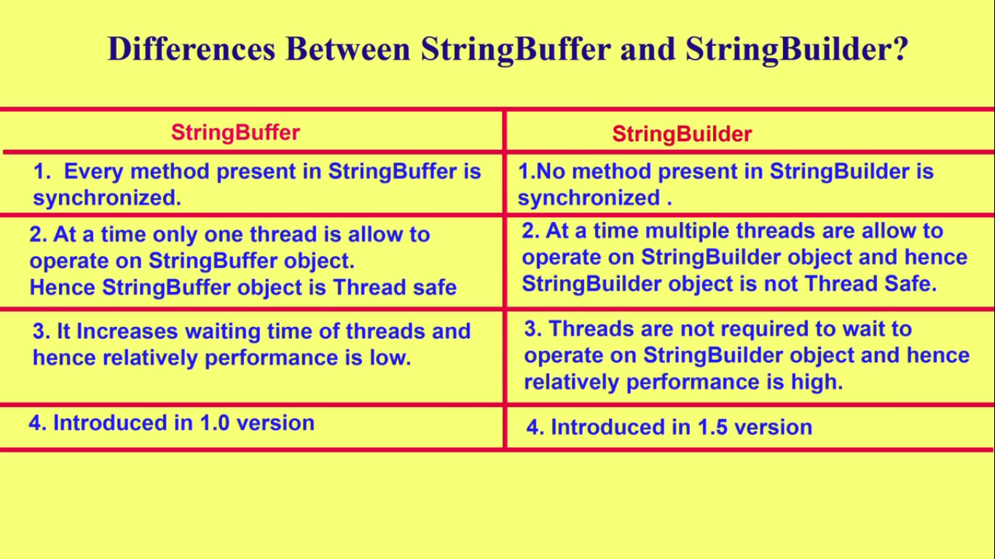

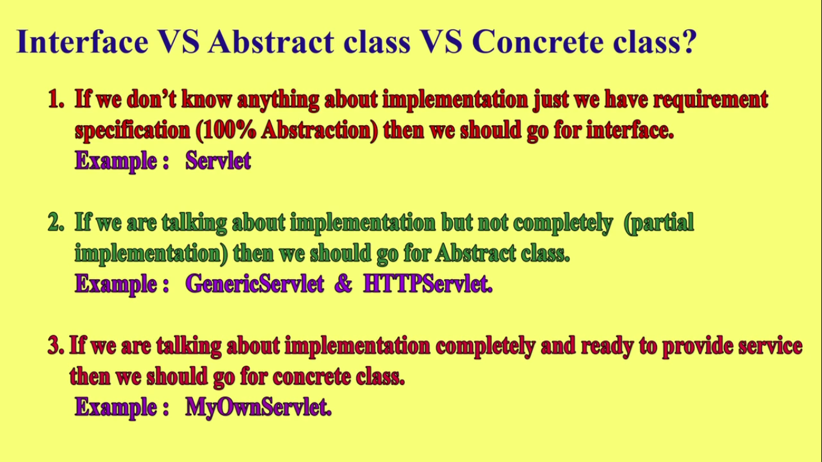

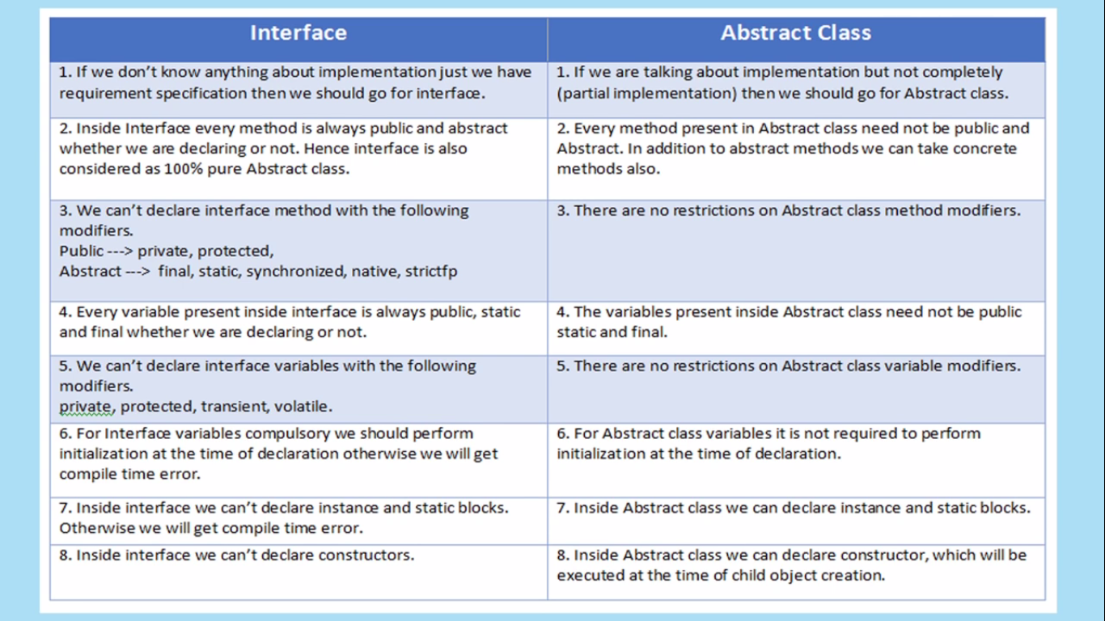

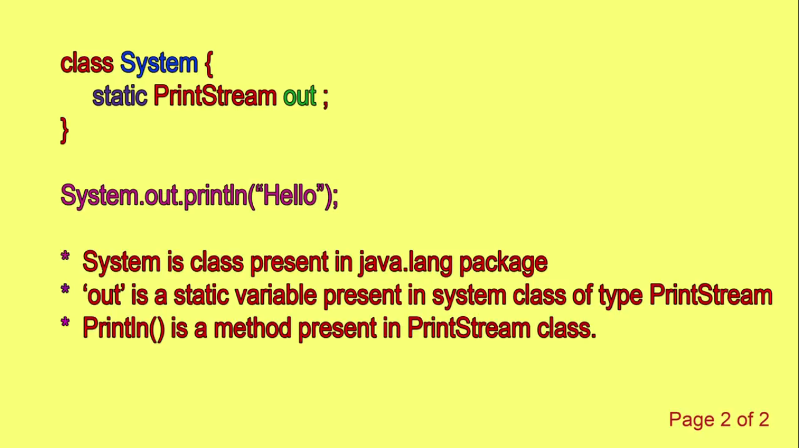

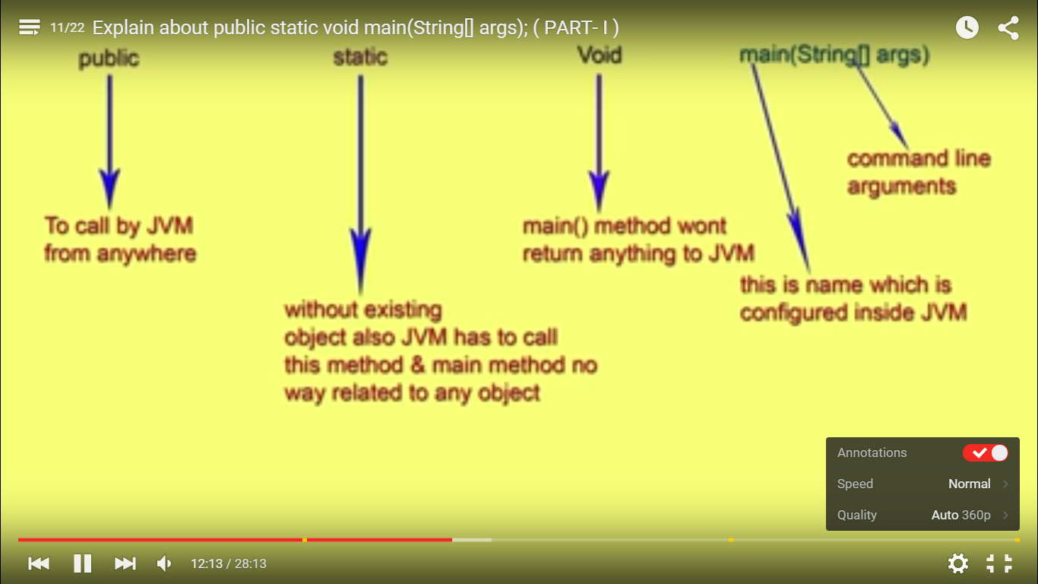

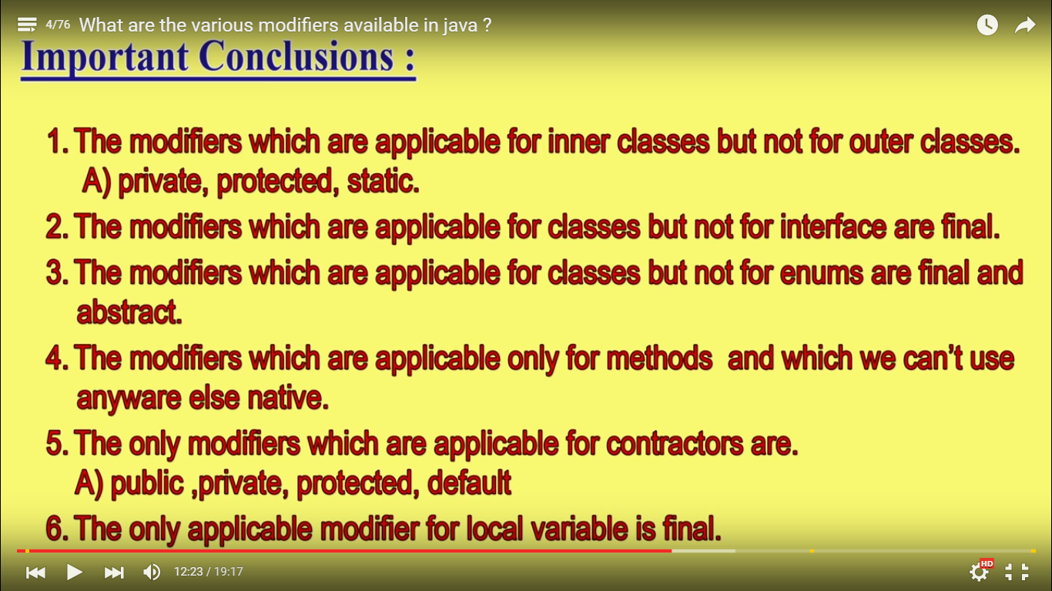

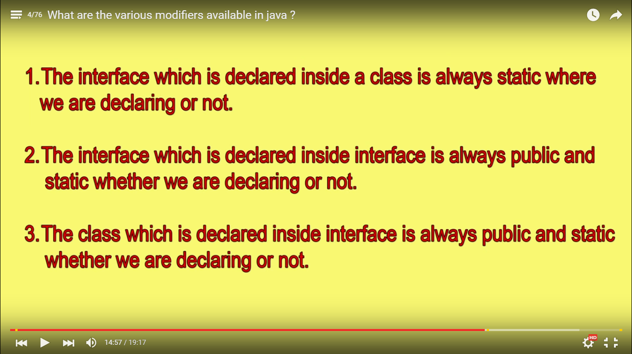

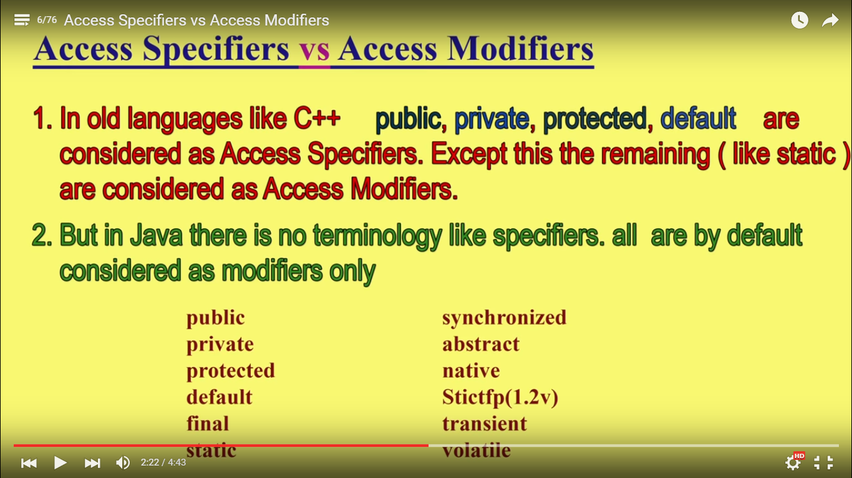

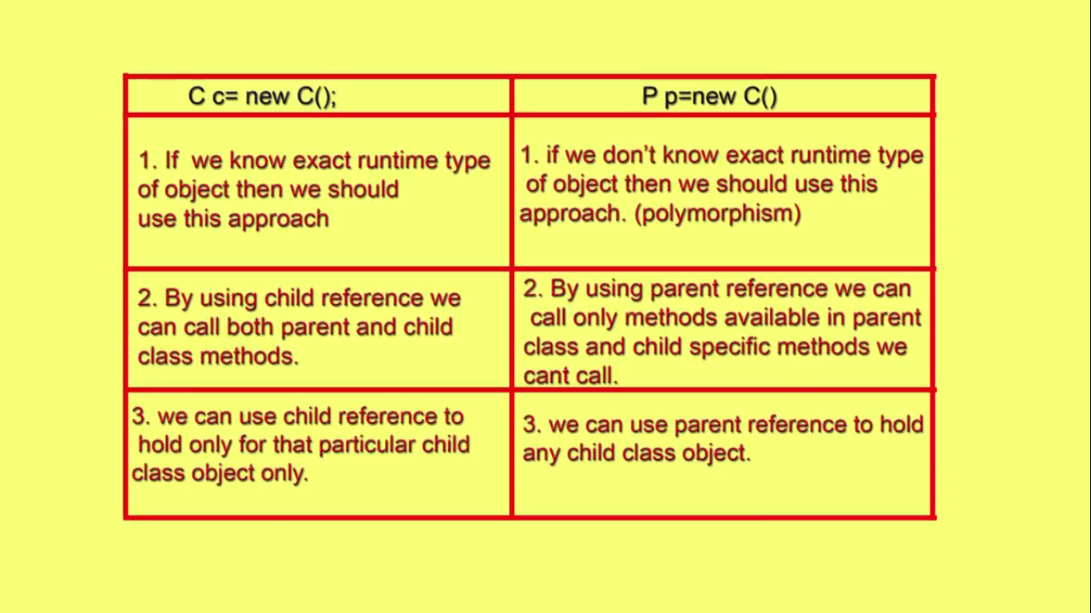

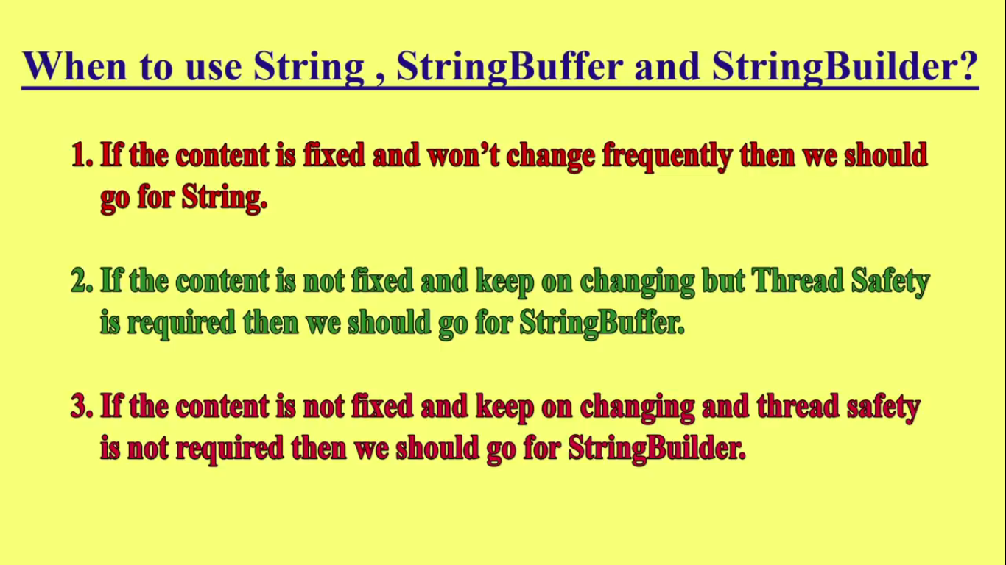

**Java transient** keyword is used in serialization. If you define any data member as transient, it will not be serialized.

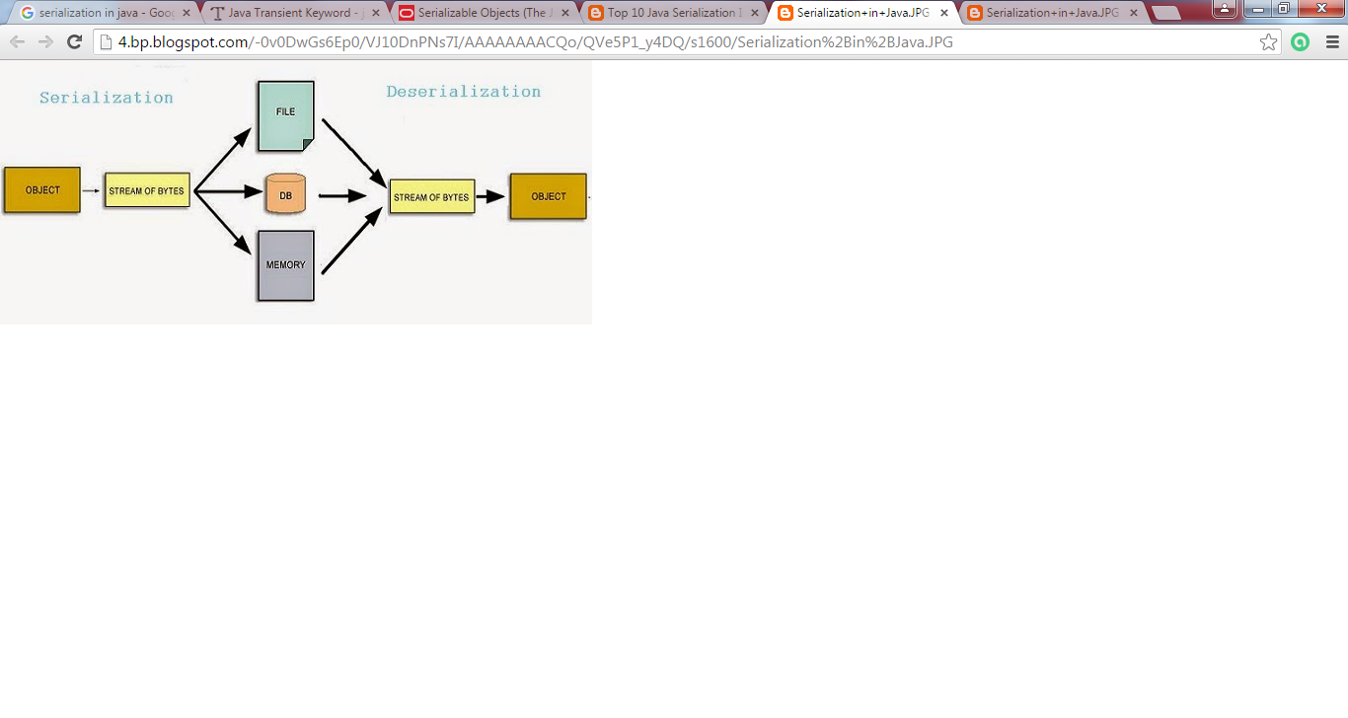 Methods of Object class

|  |
| --- |
| The Object class provides many methods. They are as follows: |

|  |  |
| --- | --- |
| **Method** | **Description** |
| **public final ClassgetClass()** | returns the Class class object of this object. The Class class can further be used to get the metadata of this class. |
| **public int hashCode()** | returns the hashcode number for this object. |
| **public boolean equals(Object obj)** | compares the given object to this object. |
| **protected Object clone() throws CloneNotSupportedException** | creates and returns the exact copy (clone) of this object. |
| **public String toString()** | returns the string representation of this object. |
| **public final void notify()** | wakes up single thread, waiting on this object's monitor. |
| **public final void notifyAll()** | wakes up all the threads, waiting on this object's monitor. |
| **public final void wait(long timeout)throws InterruptedException** | causes the current thread to wait for the specified milliseconds, until another thread notifies (invokes notify() or notifyAll() method). |
| **public final void wait(long timeout,int nanos)throws InterruptedException** | causes the current thread to wait for the specified miliseconds and nanoseconds, until another thread notifies (invokes notify() or notifyAll() method). |
| **public final void wait()throws InterruptedException** | causes the current thread to wait, until another thread notifies (invokes notify() or notifyAll() method). |
| **protected void finalize()throws Throwable** | is invoked by the garbage collector before object is being garbage collected. |

# Hashing :How Hash Map Works In Java Or How Get() Method Works Internally

**How Hashmap works in Java**  
  
HashMap works on the principle of Hashing .  To understand Hashing , we should understand the three terms first   i.e  *Hash Function , Hash Value and Bucket .*  
  
**What is Hash Function , Hash Value  and Bucket ?**  
  
hashCode() function  which returns an integer value is the **Hash function**. The important point to note that ,  this method is present in [Object class ( Mother of all class )](http://javahungry.blogspot.com/2013/06/object-class-and-methods-in-java-example-explanation.html" \t "_blank) .  
  
This is the code for the hash function(also known as hashCode method) in Object Class :  
  
    public native int hashCode();

The most important point to note from the above line :  hashCode method return  int value .  
So the **Hash value**isthe int value returned by the hash function**.**  
  
  
    So summarize the terms in the diagram below :  
                   

[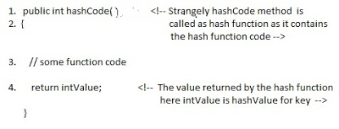](http://3.bp.blogspot.com/-ohpWRYtP3N8/UgVGHwEk3YI/AAAAAAAAAbQ/K5BKPJ8dfmQ/s1600/How+hash+map+works+.jpg)

**What is bucket ?**   
A bucket is used to store key value pairs . A bucket can have multiple key-value pairs . In hash map, bucket used simple linked list to store objects .  
  
  
  
After understanding the terms we are ready to move next step , **How hash map works in java** **or How get() works internally in java .**  
  
  
**Code inside Java Api (HashMap class internal implementation) for HashMap get(Obejct key) method**

**1**. Public V get(Object key)

{

**2**. **if** (key ==**null**)

**3**. //Some code

**4**. **int** hash = hash(key.hashCode());

**5**. // if key found in hash table then return value

**6**. // else return null

}

**Hash map** **works on the principle of hashing**  
  
HashMap get(Key k) method calls hashCode method on the key object and applies returned hashValue to its own static hash function to find a bucket location(backing array) where keys and values are stored in form of a**nested class called Entry (Map.Entry)**. So you have concluded that from the previous line that**Both key and value is stored in the bucket as a form of  Entry object**. So thinking that Only value is stored  in the bucket is not correct and will not give a good impression on the interviewer .  
  
\* Whenever we call get( Key k )  method on the HashMap object . First it checks that whether key is null or not .  Note that **there can only be one null key in HashMap .**  
 **If key is null , then Null keys always map to hash 0, thus index 0.**  
  
If key is not null then , it will call hashfunction on the key object , see line 4 in above method i.e. key.hashCode()  ,so after key.hashCode() returns hashValue , line 4 looks like  
  
4.                int hash = hash(hashValue)  
  
 , and now ,it applies returned hashValue into its own hashing function .  
  
**We might wonder why we are calculating the hashvalue again using hash(hashValue).** Answer is ,It defends against poor quality hash functions.  
  
Now step 4 final  hashvalue is used to find the bucket location at which the Entry object is stored .**Entry object stores in the bucket like this (hash,key,value,bucketindex) .**  
  
**Interviewer:    What if  when two different keys have the same hashcode ?**  
Solution, [equals() method](http://javahungry.blogspot.com/2013/06/difference-between-equals-and-double-equals-method-with-example-java-collections-interview-question.html" \t "_blank) comes to rescue.Here candidate gets puzzled. Since bucket is one and we have two objects with the same hashcode .Candidate usually forgets that bucket is a simple linked list.  
  
**The bucket is the linked list effectively . Its not a LinkedList as in a java.util.LinkedList - It's a separate (simpler) implementation just for the map .**  
  
**So we traverse through linked list , comparing keys in each entries using keys.equals() until it return true.  Then the corresponding entry object Value is returned .**

[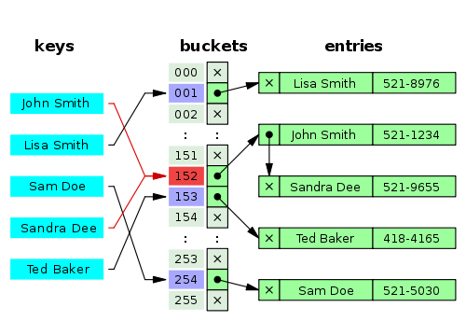](http://4.bp.blogspot.com/-unPwpp8AJTA/U0e9S0F5ljI/AAAAAAAAAUo/xMnUVRO5fyY/s1600/how+hashmap+works+internally+in+java+.png)

One of  our readers Jammy  asked a very good  question   
  
**When the functions 'equals' traverses through the linked list does it traverses from start to end one by one...in other words brute method. Or the linked list is sorted based on key and then it traverses?**  
  
Answer is when an element is added/retrieved, same procedure follows:  
  
  
a. Using key.hashCode() [ see above step 4],determine initial hashvalue for the key  
  
b. Pass intial hashvalue as hashValue  in    hash(hashValue) function, to calculate the final hashvalue.  
  
c. Final hash value is then passed as a first parameter in the indexFor(int ,int )method .  
    The second parameter is length which is a constant in HashMap Java Api , represented by                             DEFAULT\_INITIAL\_CAPACITY  
  
    The default  value of DEFAULT\_INITIAL\_CAPACITY is 16 in HashMap Java Api .  
  
 indexFor(int,int) method  returns the first entry in the appropriate bucket. The linked list in the bucket is then iterated over - (the end is found and the element is added or the key is matched and the value is returned )  
  
  
Explanation about indexFor(int,int) is below :

/\*\*

\* Returns index for hash code h.

\*/

**static** **int** **indexFor**(**int** h, **int** length) {

**return** h & (length-**1**);

}

The above function indexFor() works because Java HashMaps always have a capacity, i.e. number of buckets, as a power of 2.  
 Let's work with a capacity of 256,which is 0x100, but it could work with any power of 2. Subtracting 1  
from a power of 2 yields the exact bit mask needed to bitwise-and with the hash to get the proper bucket index, of range 0 to length - 1.  
256 - 1 = 255  
0x100 - 0x1 = 0xFF  
E.g. a hash of 257 (0x101) gets bitwise-anded with 0xFF to yield a bucket number of 1.  
  
**Interviewer:    What if  when two  keys are same and have the same hashcode ?**  
If key needs to be inserted and already inserted hashkey's hashcodes are same, and keys are also same(via reference or using equals() method)  then override the previous key value pair with the current key value pair.  
The other **important point** to note is that**in Map ,Any class(String etc.) can serve as a key if and only if it overrides the equals() and hashCode() method .**

**Interviewer:  How will you measure the performance of HashMap?**  
According to [Oracle Java docs](http://docs.oracle.com/javase/7/docs/api/java/util/HashMap.html" \t "_blank),    
  
An instance of HashMap has two parameters that affect its performance: initial capacity and load factor.   
  
The **capacity** is the number of buckets in the hash table( HashMap class is roughly equivalent to Hashtable, except that it is unsynchronized and permits nulls.), and the initial capacity is simply the capacity at the time the hash table is created.   
  
  
The **load factor** is a measure of how full the hash table is allowed to get before its capacity is automatically increased. When the number of entries in the hash table exceeds the product of the load factor and the current capacity, the hash table is rehashed (that is, internal data structures are rebuilt) so that the hash table has approximately twice the number of buckets.  
 **In HashMap class, the default value of load factor is (.75) .**  
  
**Interviewer : What is the time complexity of Hashmap get() and put() method ?**  
  
The hashmap implementation provides constant time performance for (get and put) basic operations  
i.e the complexity of get() and put() is O(1) , assuming the hash function disperses the elements properly among the buckets.   
  
**Interviewer : What is the difference between HashMap and ConcurrentHashMap ?**  
  
It is also one of the popular interview question on HashMap , you can find the answer here   
[HashMap vs ConcurrentHashMap](http://javahungry.blogspot.in/2014/02/hashmap-vs-concurrenthashmap-java-collections-interview-question.html" \t "_blank)

# Fail Fast Vs Fail Safe Iterator In Java : Java Developer Interview Questions

Difference between Fail fast and fail safe iterator  or  Fail fast vs Fail Safe iterator is one of those questions which are  used to test your knowledge about the topic Concurrency.  
Before we discuss in detail about fail safe iterator and fail fast iterator in addition to  their comparison , we should understand the term*Concurrent Modification*.  
  
**What is Concurrent Modification ?**  
  
When one or more thread is iterating over the collection, in between, one thread changes the structure of the collection (either adding the element to the collection or by deleting the element in the collection or by updating the value at particular position in the collection) is known as Concurrent Modification  
  
**Difference between Fail Fast iterator and Fail Safe iterator**  
  
**Fail fast Iterator**  
  
Fail fast iterator while iterating through the collection , instantly throws Concurrent Modification Exception if there is structural modification  of the collection . Thus, in the face of concurrent modification, the iterator fails quickly and cleanly, rather than risking arbitrary, non-deterministic behavior at an undetermined time in the future.   
  
Fail-fast iterator can throw ConcurrentModificationException in two scenarios :

[](http://2.bp.blogspot.com/-Kq93JFHmFko/Uz1PCGYvh6I/AAAAAAAAAUA/mypfiEE8Jsk/s1600/difference+between+fail+fast+iterator+and+fail+safe+iterator+.jpg)

*Single Threaded Environment*  
   
After the creation of the iterator , structure is modified at any time by any method other than iterator's own remove method.   
   
*Multiple Threaded Environment*  
  
 If one thread is modifying the structure of the collection while other thread is iterating over it .  
  
  
According to  [Oracle docs](http://docs.oracle.com/javase/7/docs/api/java/util/HashMap.html" \t "_blank) , **the fail-fast behavior of an iterator cannot be guaranteed** as it is, generally speaking, impossible to make any hard guarantees in the presence of unsynchronized concurrent modification. Fail-fast iterators throw ConcurrentModificationException on a best-effort basis. Therefore, it would be wrong to write a program that depended on this exception for its correctness:**the fail-fast behavior of iterators should be used only to detect bugs.**  
  
  
**Interviewer : How  Fail  Fast Iterator  come to know that the internal structure is modified ?**  
Iterator read internal data structure (object array) directly . The internal data structure(i.e object array) should not be modified while iterating through the collection. To ensure this it maintains an internal  flag *"mods" .*Iterator checks the *"mods" flag*whenever it gets the next value (using hasNext() method and next() method). Value of*mods* flag changes whenever there is an structural modification. Thus indicating iterator to throw ConcurrentModificationException.  
  
  
**Fail Safe Iterator :**  
  
Fail Safe Iterator makes copy of the internal data structure (object array) and iterates over the copied data structure.Any structural modification done to the iterator affects the copied data structure.  So , original data structure remains  structurally unchanged .Hence , no ConcurrentModificationException throws by the fail safe iterator.  
  
Two  issues associated with Fail Safe Iterator are :  
  
1. Overhead of maintaining the copied data structure i.e memory.  
  
2.  Fail safe iterator does not guarantee that the data being read is the data currently in the original data structure.   
  
According to [Oracle docs](http://docs.oracle.com/javase/7/docs/api/java/util/concurrent/CopyOnWriteArrayList.html" \t "_blank) , fail safe iterator is ordinarily too costly, but may be more efficient than alternatives when traversal operations vastly outnumber mutations, and is useful when you cannot or don’t want to synchronize traversals, yet need to preclude interference among concurrent threads. The "snapshot" style iterator method uses a reference to the state of the array at the point that the iterator was created. This **array never changes during the lifetime of the iterator, so interference is impossible and the iterator is guaranteed not to throw ConcurrentModificationException**.The iterator will not reflect additions, removals, or changes to the list since the iterator was created. Element-changing operations on iterators themselves (remove(), set(), and add()) are not supported. These methods throw UnsupportedOperationException.  
  
  
  
**Example of Fail Fast Iterator and Fail Safe Iterator**

**import** **java.util.HashMap**;

**import** **java.util.Iterator**;

**import** **java.util.Map**;

**public** **class** **FailFastExample**

{

**public** **static** **void** **main**(String[] args)

{

Map<String,String> premiumPhone = **new** HashMap<String,String>();

premiumPhone.put("Apple", "iPhone");

premiumPhone.put("HTC", "HTC one");

premiumPhone.put("Samsung","S5");

Iterator iterator = premiumPhone.keySet().iterator();

**while** (iterator.hasNext())

{

System.out.println(premiumPhone.get(iterator.next()));

premiumPhone.put("Sony", "Xperia Z");

}

}

}

**Output :**

iPhone

Exception in thread "main" java.util.ConcurrentModificationException

at java.util.HashMap$HashIterator.nextEntry(Unknown Source)

at java.util.HashMap$KeyIterator.next(Unknown Source)

at FailFastExample.main(FailFastExample.java:**20**)

**Fail Safe Iterator Example :**

**import** **java.util.concurrent.ConcurrentHashMap**;

**import** **java.util.Iterator**;

**public** **class** **FailSafeExample**

{

**public** **static** **void** **main**(String[] args)

{

ConcurrentHashMap<String,String> premiumPhone =

**new** ConcurrentHashMap<String,String>();

premiumPhone.put("Apple", "iPhone");

premiumPhone.put("HTC", "HTC one");

premiumPhone.put("Samsung","S5");

Iterator iterator = premiumPhone.keySet().iterator();

**while** (iterator.hasNext())

{

System.out.println(premiumPhone.get(iterator.next()));

premiumPhone.put("Sony", "Xperia Z");

}

}

}

**Output :**

S5

HTC one

iPhone

**Recap : Difference between Fail Fast Iterator and Fail Safe Iterator**

|  |  |  |
| --- | --- | --- |
|  | **Fail Fast Iterator** | **Fail Safe Iterator** |
| Throw ConcurrentModification Exception | Yes | No |
| Clone object | No | Yes |
| Memory Overhead | No | Yes |
| Examples | HashMap,Vector,ArrayList,HashSet | CopyOnWriteArrayList, ConcurrentHashMap |

# How ConcurrentHashMap Internally Works In Java With Example

How ConcurrentHashMap works or internal implementation of ConcurrentHashMap is one of the most popular java interview questions under the category concurrency. We have already discussed the other popular java interview questions like  [internal working of HashSet](http://javahungry.blogspot.com/2013/08/how-sets-are-implemented-internally-in.html" \t "_blank) or [How  HashMap works in java](http://javahungry.blogspot.com/2013/08/hashing-how-hash-map-works-in-java-or.html" \t "_blank) .  
  
ConcurrentHashMap utilizes the same principles of HashMap, but is designed primarily for a multi-threaded application and hence it does not require explicit synchronization.   The only thread safe collection objects were Hashtable and synchronized Map prior to JDK 5.   
  
Before learning How ConcurrentHashMap works in Java , we need to look at why ConcurrentHashMap is added to the Java SDK.  
  
**Interviewer : Why we need ConcurrentHashMap when we already had Hashtable ?**  
  
Hashtable provides concurrent access to the Map.Entries objects by locking the entire map to perform any sort of operation (update,delete,read,create). Suppose we have a web application , the overhead created by Hashtable  (locking the entire map) can be ignored under normal load. But under heavy load , the overhead of locking the entire map may prove fatal and may lead to delay response time and   overtaxing of the server.

This  is where ConcurrentHashMap comes to rescue. According to[ConcurrentHashMap Oracle docs,](http://docs.oracle.com/javase/7/docs/api/java/util/concurrent/ConcurrentHashMap.html" \t "_blank)  
ConcurrentHashMap class is fully interoperable with Hashtable in programs that rely on its thread safety but not on its synchronization details. So the main purpose of this class is to provide the same functionality as of Hashtable but with a performance comparable to HashMap.   
  
ConcurrentHashMap achieves this by a simple tweak. So this leads to our main question

**How ConcurrentHashMap works in Java**  
  
According to ConcurrentHashMap Oracle docs,   
  
The constructor of ConcurrentHashMap looks like this :  
  
**public ConcurrentHashMap*(int initialCapacity, float loadFactor, int concurrencyLevel)***  
  
So the above line  creates a new, empty map with the specified initial capacity, load factor and concurrency level.

where,

**Important Parameters to consider from ConcurrentHashMap Constructor:**

**initialCapacity** - the initial capacity. The implementation performs *internal sizing to accommodate this many elements.*  
**concurrencyLevel** - the estimated number of concurrently updating threads. The implementation performs *internal sizing to try to accommodate this many threads.*

In the [ConcurrentHashMap Api](http://www.docjar.com/html/api/java/util/concurrent/ConcurrentHashMap.java.html" \t "_blank) , you will find the following constants.

static final int DEFAULT\_INITIAL\_CAPACITY = 16;

static final int DEFAULT\_CONCURRENCY\_LEVEL = 16;

initial capacity parameter and concurrency level parameters of ConcurrentHashMap constructor (or Object) are  set to 16 by default.  
  
Thus, instead of a map wide lock, ConcurrentHashMap maintains  a list of 16 locks by default ( number of locks equal to the initial capacity , which is by default  16) each of which is used to lock on a single bucket of the Map.This indicates that 16 threads (number of threads equal to the concurrency level , which is by  default 16) can modify the collection at the same time , given ,each thread works on different bucket. So unlike hashtable, we perform any sort of operation ( update ,delete ,read ,create) without locking on entire map in ConcurrentHashMap.  
  
Retrieval operations (including get) generally do not block, so may overlap with update operations (including put and remove). Retrievals reflect the results of the most recently *completed* update operations holding upon their onset.   
  
The allowed concurrency among update operations is guided by the optional concurrencyLevel constructor argument (default 16), which is used as a hint for internal sizing. The table is internally partitioned to try to permit the indicated number of concurrent updates without contention. Because placement in hash tables is essentially random, the actual concurrency will vary. Ideally, you should choose a value to accommodate as many threads as will ever concurrently modify the table. Using a significantly higher value than you need can waste space and time, and a significantly lower value can lead to thread contention  
  
**Interviewer : Can two threads update the ConcurrentHashMap simultaneously ?**  
  
                                                       
Yes it is possible that two threads can simultaneously write on the ConcurrentHashMap. ConcurrentHashMap default implementation allows 16 threads to read and write in parallel.   
But in the worst case scenario , when two objects lie in the same segment or same partition, then parallel write would not be possible.  
  
**Interviewer : Why ConcurrentHashMap does not allow null keys and null values ?**  
  
According to the [author of the ConcurrentHashMap (Doug lea himself)](http://cs.oswego.edu/pipermail/concurrency-interest/2006-May/002485.html" \t "_blank)

The main reason that nulls aren't allowed in ConcurrentMaps (ConcurrentHashMaps, ConcurrentSkipListMaps) is that ambiguities that may be just barely tolerable in non-concurrent maps can't be accommodated. The main one is that if map.get(key) returns null, you can't detect whether the key explicitly maps to null vs the key isn't mapped. In a non-concurrent map, you can check this via map.contains(key), but in a concurrent one, the map might have changed between   
calls.  
  
In simple words,   
  
The code is like this :   
 

**if** (map.containsKey(k)) {

**return** map.get(k);

} **else** {

**throw** **new** **KeyNotPresentException**();

}

It might be possible that key k might be deleted in between the get(k) and containsKey(k) calls. As a result , the code will return null as opposed to KeyNotPresentException (Expected Result if key is not present).   
  
**Interviewer : What is the difference between HashMap and ConcurrentHashMap?**  
  
The HashMap was not thread safe and therefore could not be utilized in multi-threaded applications.  The ConcurrentHashMap was introduced to overcome this shortcoming and also as an alternative to using HashTable and synchronized Maps for greater performance and uses the standard Hashing algorithms to generate hash code for storing the key value pairs.For more difference between HashMap and ConcurrentHashMap check this [popular interview question HashMap vs ConcurrentHashMap in java](http://javahungry.blogspot.com/2014/02/hashmap-vs-concurrenthashmap-java-collections-interview-question.html" \t "_blank).  
  
  
  
**Interviewer : Can multiple threads read from the Hashtable concurrently ?**  
  
No multiple threads can not read simultaneously from Hashtable. Reason, the get() method of  Hashtable is synchronized. As a result , at a time only one thread can access the get() method .  
It is possible to achieve full  concurrency for reads (all the threads read at the same time) in  ConcurrentHashMap by using volatile keyword.  
  
**Interviewer: Does ConcurrentHashMap Iterator behaves like fail fast iterator or fail safe Iterator?**   
  
ConcurrentHashMap iterator behaves like fail safe iterator. It will not throw ConcurrentModificationException . We have already discussed [Fail Fast Iterator vs Fail Safe Iterator](http://javahungry.blogspot.com/2014/04/fail-fast-iterator-vs-fail-safe-iterator-difference-with-example-in-java.html" \t "_blank).  
  
  
**Interviewer : Why does Java provide default value of partition count as 16 instead of very high value ?**  
  
According to Java docs ,

[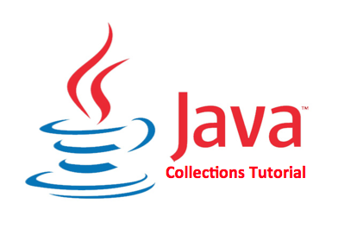](http://1.bp.blogspot.com/-WsUtI3c7wrQ/Uu9tohX5HLI/AAAAAAAAAJw/9PMdWlBvu-s/s1600/java-collections-tutorial.png)

Ideally, you should choose a value to accommodate as many threads as will ever concurrently modify the table. Using a significantly higher value than you need can waste space and time, and a significantly lower value can lead to thread contention.  
  
  
  
  
**Interviewer : Can you write the simple  example which proves ConcurrentHashMap class behaves like fail safe iterator?**  
  
  
**ConcurrentHashMap Example :**

**import** **java.util.concurrent.ConcurrentHashMap**;

**import** **java.util.Iterator**;

**public** **class** **ConcurrentHashMapExample**

{

**public** **static** **void** **main**(String[] args)

{

ConcurrentHashMap<String,String> premiumPhone = **new** ConcurrentHashMap<String,String>();

premiumPhone.put("Apple", "iPhone6");

premiumPhone.put("HTC", "HTC one");

premiumPhone.put("Samsung","S6");

Iterator iterator = premiumPhone.keySet().iterator();

**while** (iterator.hasNext())

{

System.out.println(premiumPhone.get(iterator.next()));

premiumPhone.put("Sony", "Xperia Z");

}

}

}

**Output :**

S6

HTC one

iPhone6

Please mention in the comments in case you have any doubts regarding the internal implementation of ConcurrentHashMap.

Programs:

* 1. Fiboncaii

|  |  |
| --- | --- |
| |  | | --- | | 1. public class MyFibonacci { 3. public static void main(String a[]){ 5. int febCount = 15; 6. int[] feb = new int[febCount]; 7. feb[0] = 0; 8. feb[1] = 1; 9. for(int i=2; i < febCount; i++){ 10. feb[i] = feb[i-1] + feb[i-2]; 11. } 13. for(int i=0; i< febCount; i++){ 14. System.out.print(feb[i] + " "); 15. } 16. } 17. } | |

2.Bubble sort

1. **private** **static** **void** bubbleSort(**int**[] intArray) {
3. */\**
4. *\* In bubble sort, we basically traverse the array from first*
5. *\* to array\_length - 1 position and compare the element with the next one.*
6. *\* Element is swapped with the next element if the next element is greater.*
7. *\**
8. *\* Bubble sort steps are as follows.*
9. *\**
10. *\* 1. Compare array[0] & array[1]*
11. *\* 2. If array[0] > array [1] swap it.*
12. *\* 3. Compare array[1] & array[2]*
13. *\* 4. If array[1] > array[2] swap it.*
14. *\* ...*
15. *\* 5. Compare array[n-1] & array[n]*
16. *\* 6. if [n-1] > array[n] then swap it.*
17. *\**
18. *\* After this step we will have largest element at the last index.*
19. *\**
20. *\* Repeat the same steps for array[1] to array[n-1]*
21. *\**
22. *\*/*
24. **int** n = intArray.length;
25. **int** temp = 0;
27. **for**(**int** i=0; i < n; i++){
28. **for**(**int** j=1; j < (n-i); j++){
30. **if**(intArray[j-1] > intArray[j]){
31. *//swap the elements!*
32. temp = intArray[j-1];
33. intArray[j-1] = intArray[j];
34. intArray[j] = temp;
35. }
37. }
38. }
40. }
41. }

public class MyBinarySearch {

    public int binarySearch(int[] inputArr, int key) {

        int start = 0;

        int end = inputArr.length - 1;

        while (start <= end) {

            int mid = (start + end) / 2;

            if (key == inputArr[mid]) {

                return mid;

            }

            if (key < inputArr[mid]) {

                end = mid - 1;

            } else {

                start = mid + 1;

            }

        }

        return -1;

    }

    public static void main(String[] args) {

        MyBinarySearch mbs = new MyBinarySearch();

        int[] arr = {2, 4, 6, 8, 10, 12, 14, 16};

        System.out.println("Key 14's position: "+mbs.binarySearch(arr, 14));

        int[] arr1 = {6,34,78,123,432,900};

        System.out.println("Key 432's position: "+mbs.binarySearch(arr1, 432));

    }

}

- See more at: <http://java2novice.com/java-search-algorithms/binary-search/#sthash.7McdO61z.dpuf>

package com.java2novice.algos;

import java.io.BufferedReader;

import java.io.DataInputStream;

import java.io.FileInputStream;

import java.io.FileNotFoundException;

import java.io.IOException;

import java.io.InputStreamReader;

import java.util.ArrayList;

import java.util.List;

import java.util.StringTokenizer;

public class MyDistinctFileWords {

    public List<String> getDistinctWordList(String fileName){

        FileInputStream fis = null;

        DataInputStream dis = null;

        BufferedReader br = null;

        List<String> wordList = new ArrayList<String>();

        try {

            fis = new FileInputStream(fileName);

            dis = new DataInputStream(fis);

            br = new BufferedReader(new InputStreamReader(dis));

            String line = null;

            while((line = br.readLine()) != null){

                StringTokenizer st = new StringTokenizer(line, " ,.;:\"");

                while(st.hasMoreTokens()){

                    String tmp = st.nextToken().toLowerCase();

                    if(!wordList.contains(tmp)){

                        wordList.add(tmp);

                    }

                }

            }

        } catch (FileNotFoundException e) {

            e.printStackTrace();

        } catch (IOException e) {

            e.printStackTrace();

        } finally{

            try{if(br != null) br.close();}catch(Exception ex){}

        }

        return wordList;

    }

    public static void main(String a[]){

        MyDistinctFileWords distFw = new MyDistinctFileWords();

        List<String> wordList = distFw.getDistinctWordList("C:/sample.txt");

        for(String str:wordList){

            System.out.println(str);

        }

    }

}

- See more at: <http://www.java2novice.com/java-interview-programs/distinct-word-list/#sthash.bKOoVtRx.dpuf>

## Eager Initialization Lazy Initialization

To increase the performance while retrieving records from a database table, **Hibernate** uses two styles – **Eager Initialization** and **Lazy Initialization**. Concept-wise, a good programming practice is lazy initialization; but both have their own importance in coding.

**Lazy initialization (or instantiation)**

There are two types of initializations in a programming language – **eager** initialization and**lazy** initialization. In eager initialization, the object is created in the program execution, in a normal way, which sometimes the programmer may not use it in the program. This looks waste of memory and processor time. Other way is to create the object when the programmer really requires. This is called lazy initialization (one of the design patterns). That is, **if the object is created at runtime, only when the programmer requires is known as lazy initialization.**So, which is preferred, definitely you say lazy initialization. Lazy initialization is basically meant for improving the performance by avoiding unnecessary computation (load on the microprocessor) and reducing memory requirements.

**Some examples:**

**1.** Suppose you have **Customer** object having a big array of orders to display. To display the list to the customer it is very expensive as it requires **lot of hits** to database. It the **Customer**object is initialized at the beginning of the program which later found that Customer never asks to display his orders. Now, as you can guess, **it is the time for lazy initialization**.

**2.** Another scenario is when an object is very expensive (takes long time to create) to create, if you would like to defer (delay) its creation due to other more expensive operations takes place. Say, your program creates many object instances when it starts, but a few are required immediately. Now **lazy initialization**is the time to think to increase the startup performance of the program by delaying the initialization after the required and preferred objects have been created. Let us take a small code:



|  |  |
| --- | --- |
| 1  2  3  4  5  6  7  8  9  10  11  12  13  14 | public class Demo  {    private Player newPlayer = new Player();         // object is created well in advance      public Player getPlayer()    {      return newPlayer;    }    public static void main(String args[])    {      Demo d1 = new Demo();      Player p1 = d1.getPlayer();    }  } |

When you see this above code, after knowing what is **lazy initialization**, definitely you say it is meaningless, as the **newPlayer** object is created at the startup of the program itself which may not be required later (wasting its creation time).

The above code is modified as follows for lazy initialization.



|  |  |
| --- | --- |
| 1  2  3  4  5  6  7  8  9  10  11  12  13  14  15  16  17  18 | public class Demo  {    private Player newPlayer;      public Player getPlayer()    {      if(newPlayer == null)      {        newPlayer = new Player();          // object is created when asked      }      return newPlayer;    }    public static void main(String args[])    {      Demo d1 = new Demo();      Player p1 = d1.getPlayer();    }  } |

In the above code, the creation of **newPlayer** object is delayed making sure we do not create it until it is required.